Tour ID: 225060  
Tour Name: Iceland in Depth

Tour destinations: ['Reykjavik', 'Patreksfjordur', 'Isafjordur', 'Saudarkrokur', 'Siglufjordur', 'Husavik', 'Grimsey', 'Seydisfjordur', 'Heimaey Island']

Tour destinations images:

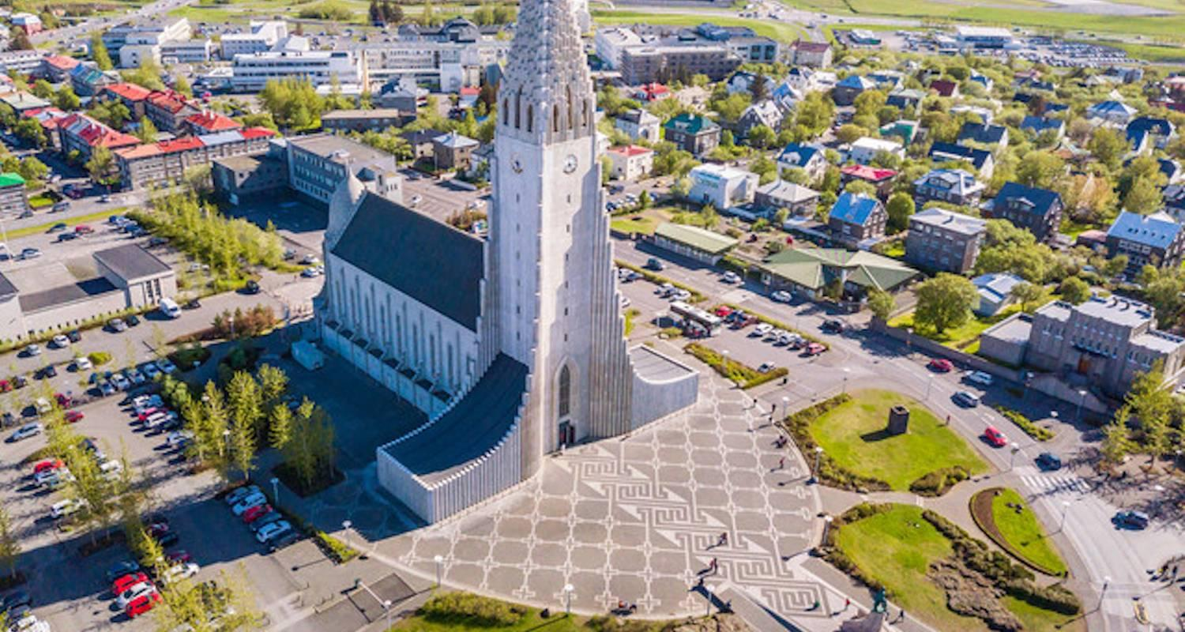

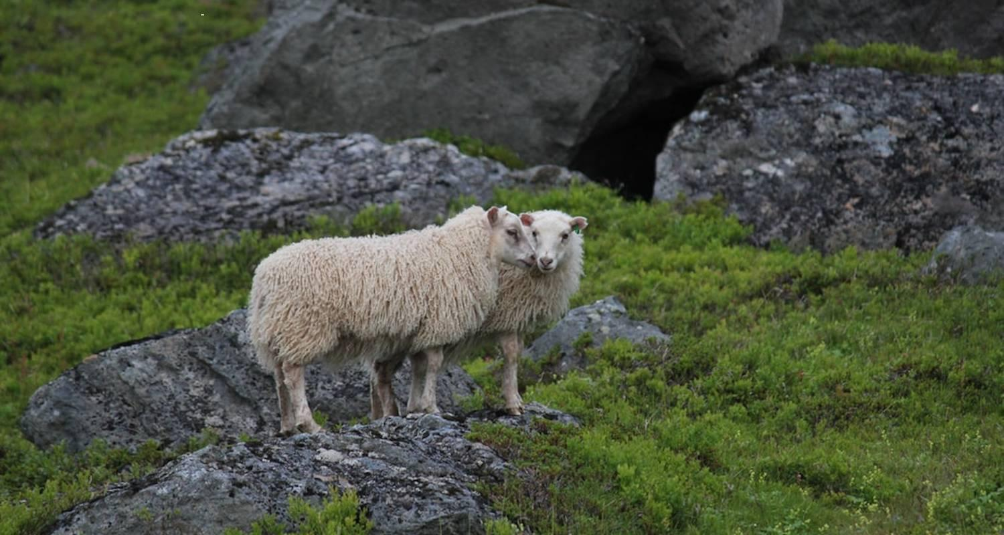

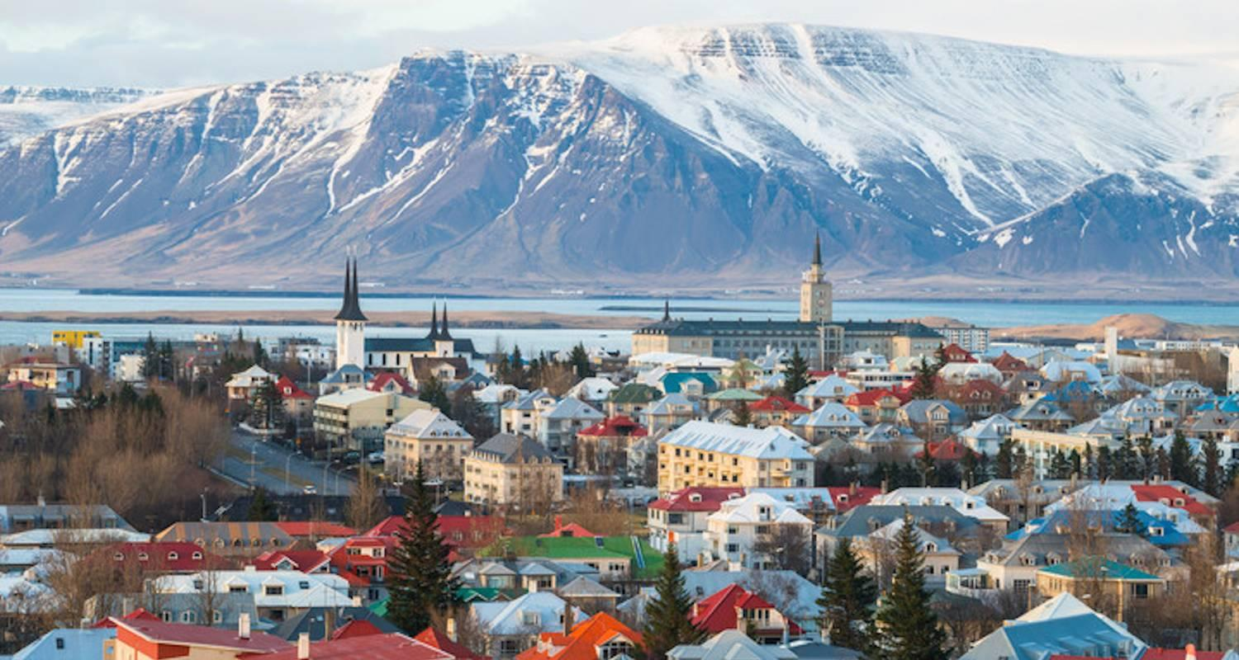

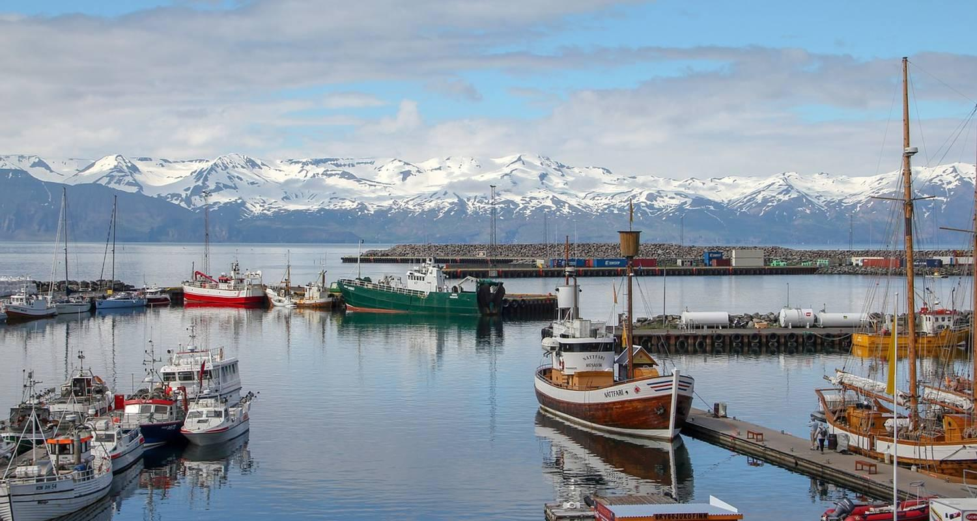

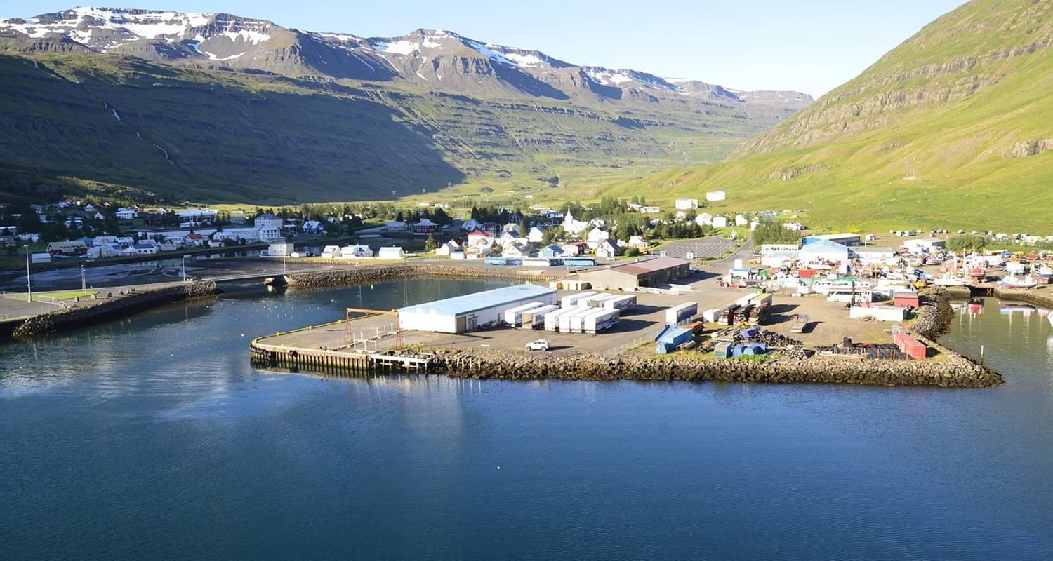

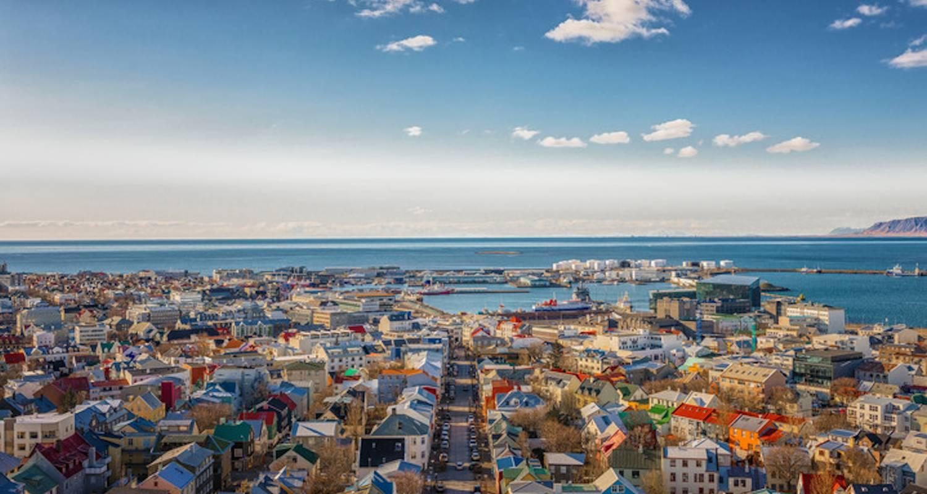

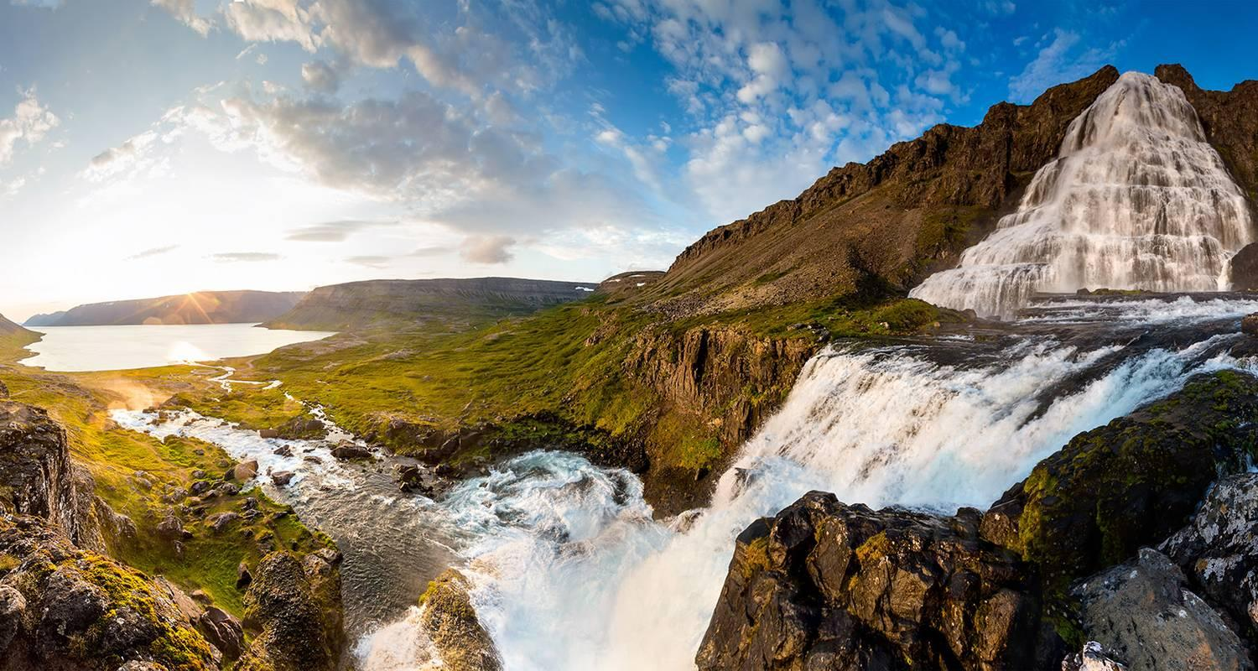

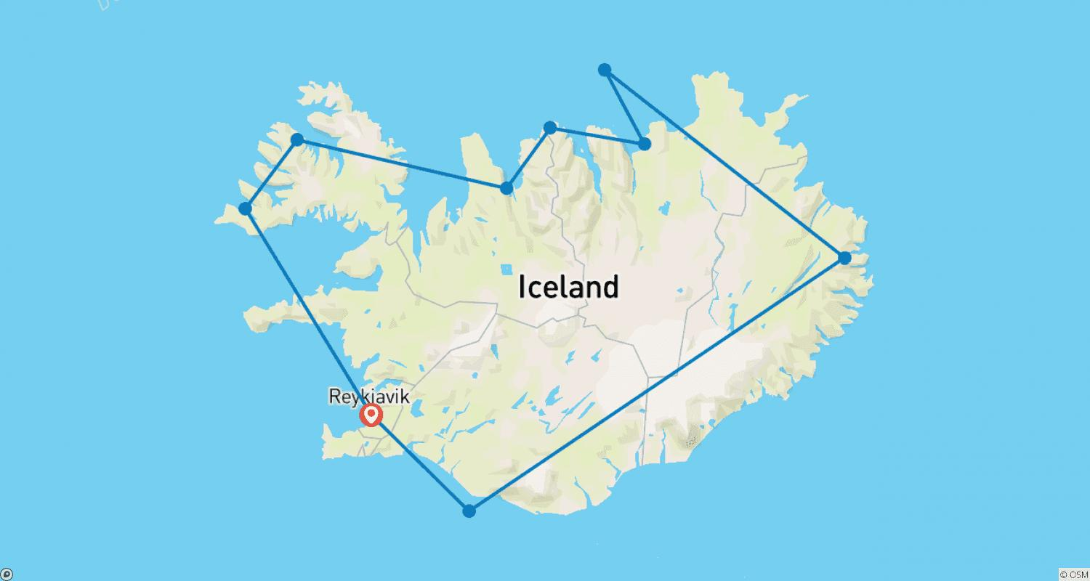

Tour ID: 225079  
Tour Name: Eastern Greenland & Iceland Expedition

Tour destinations: ['Reykjavik', 'Isafjordur', 'Ittoqqortoormiit', 'Kong Oscar Fjord']

Tour destinations images:

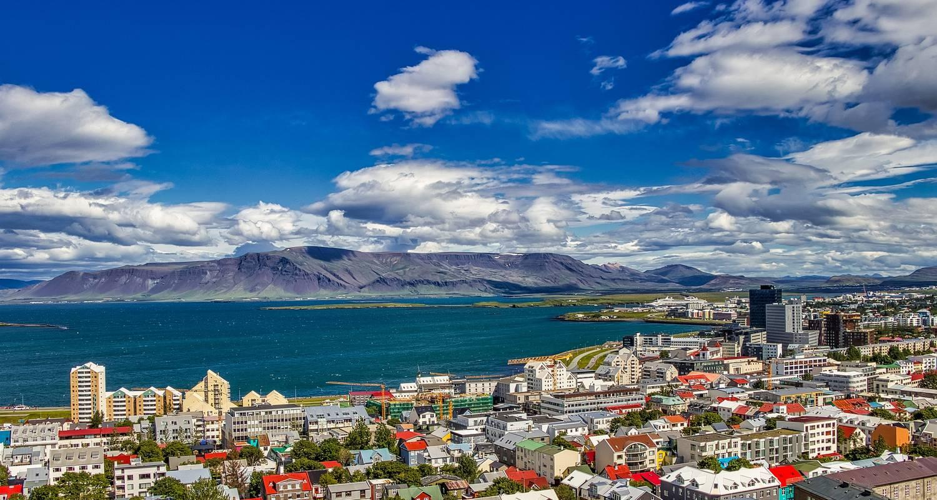

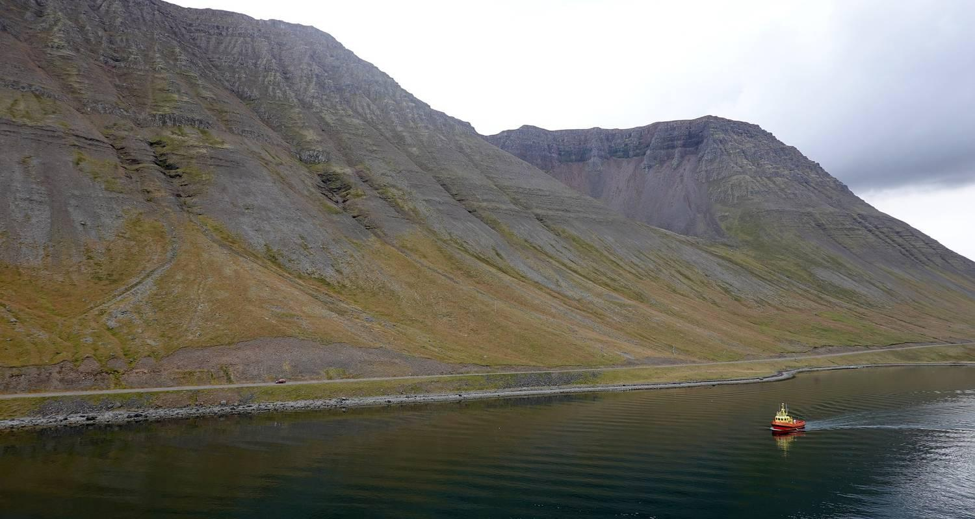

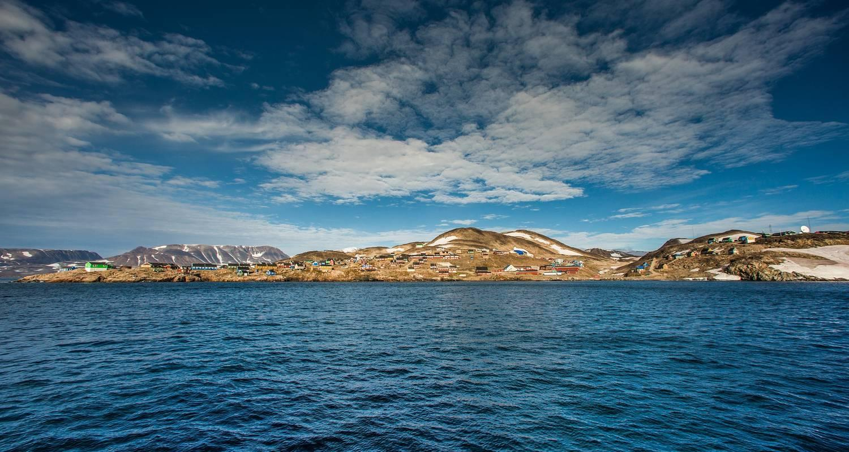

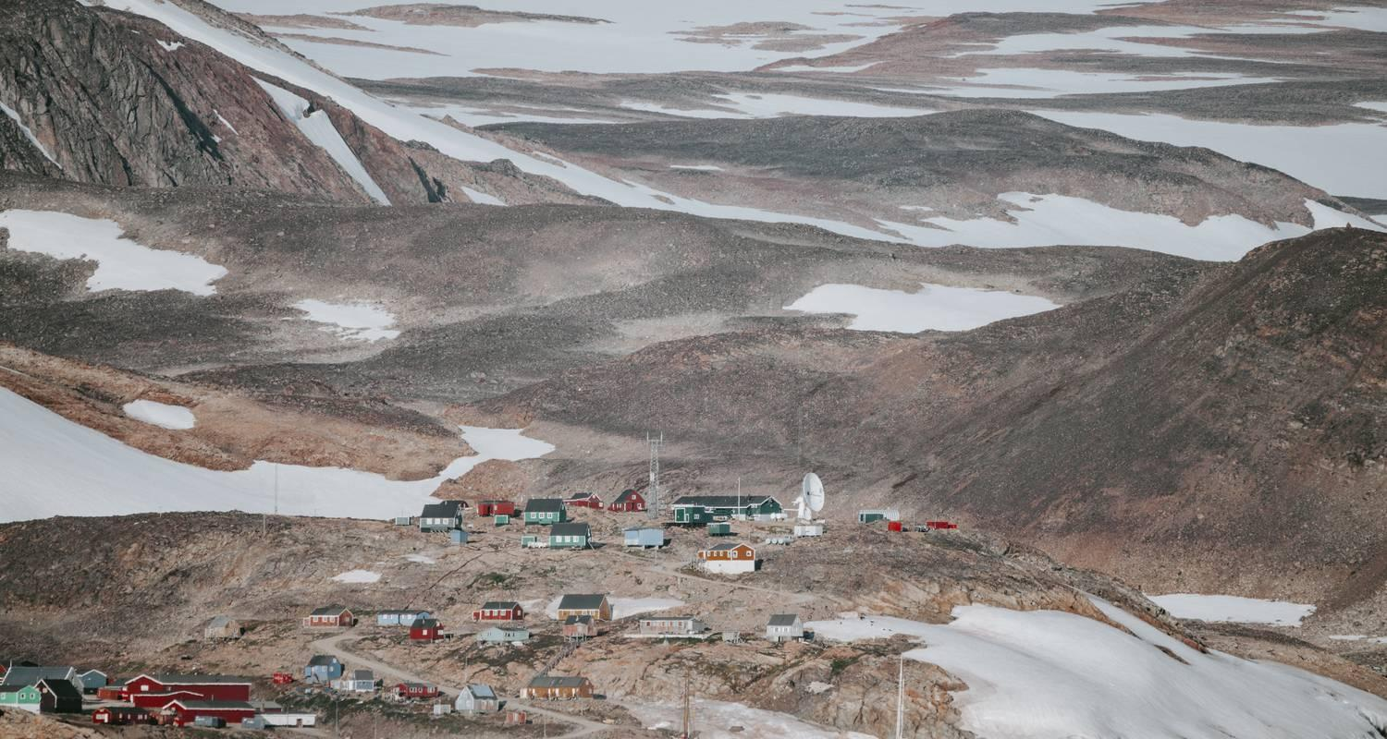

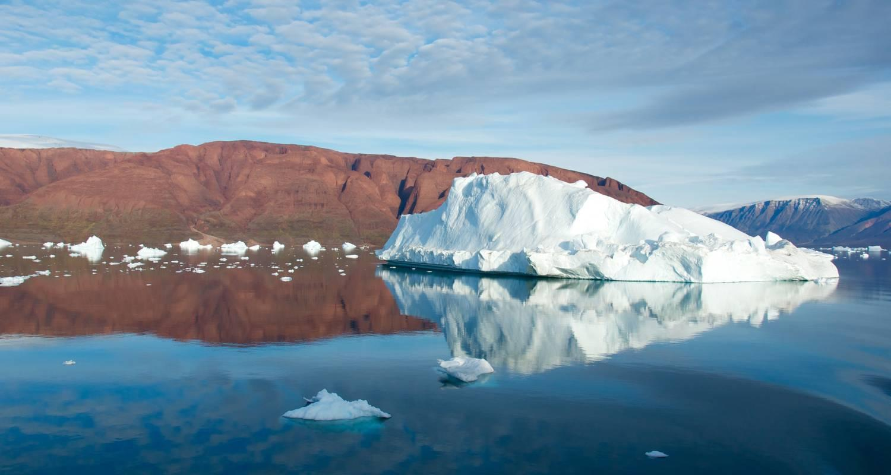

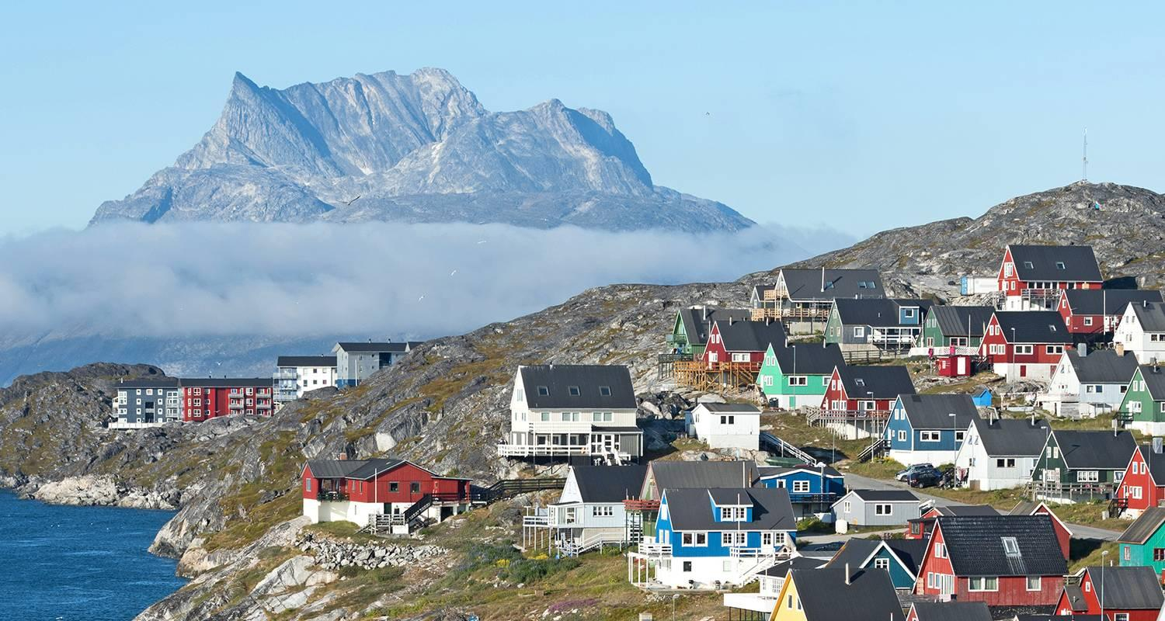

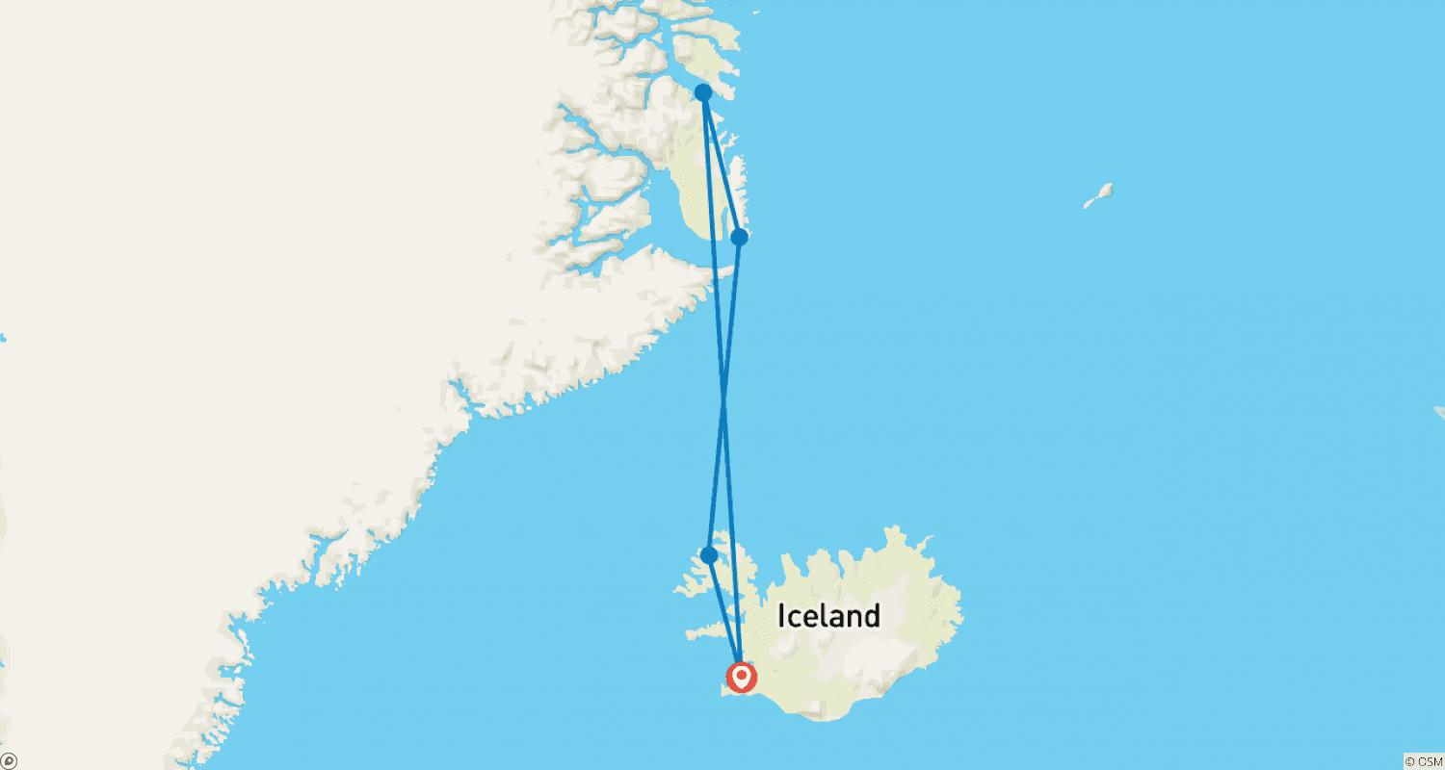

Tour ID: 225081  
Tour Name: Greenland Explorer

Tour destinations: ['Reykjavik', 'Skjoldungen', 'Prins Christianssund', 'Narsaq', 'Nuuk', 'Ilulissat', 'Upernavik', 'Disko Bay', 'Sisimiut', 'Kangerlussuaq', 'Copenhagen']

Tour destinations images:

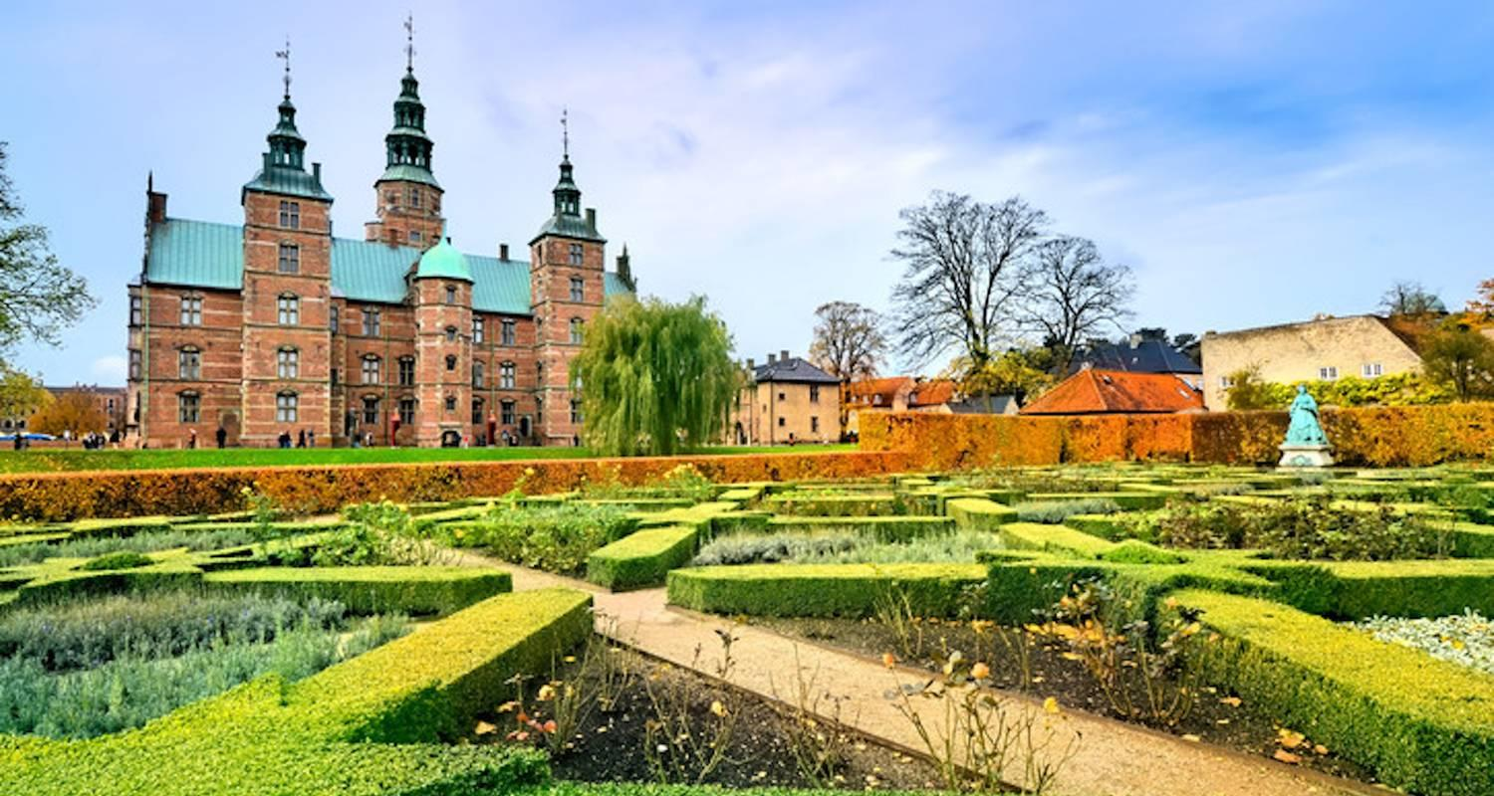

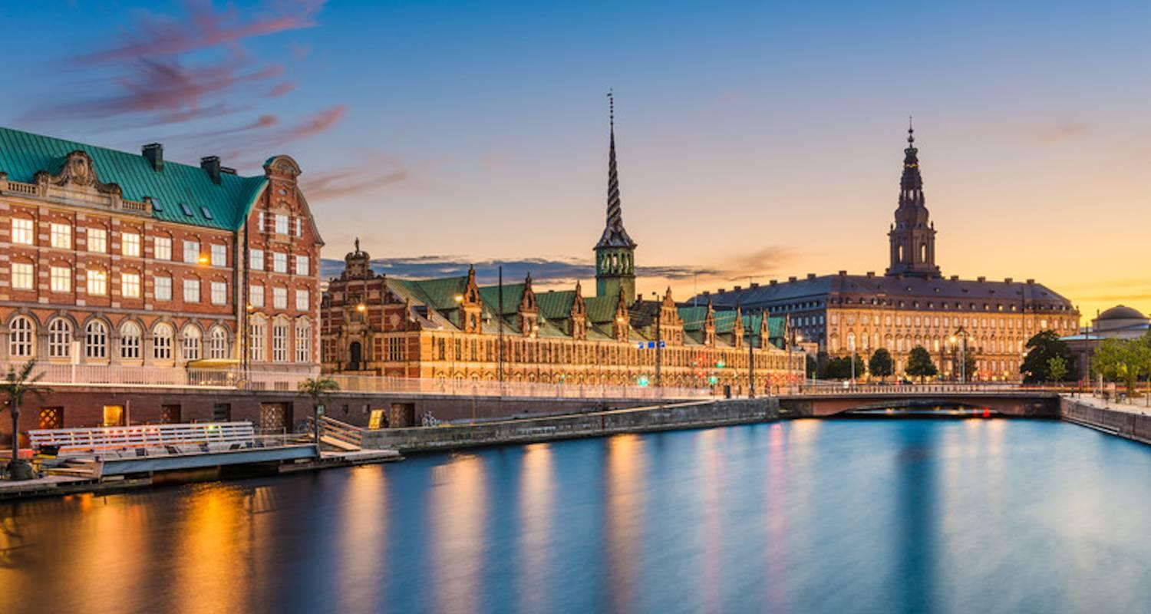

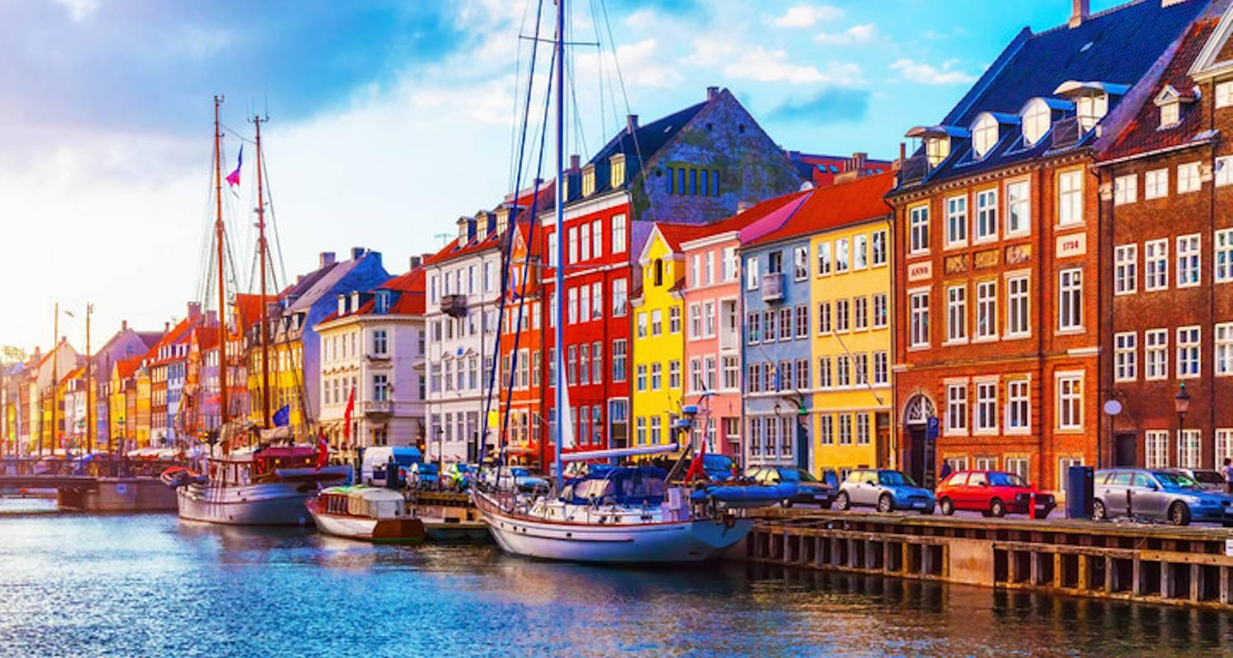

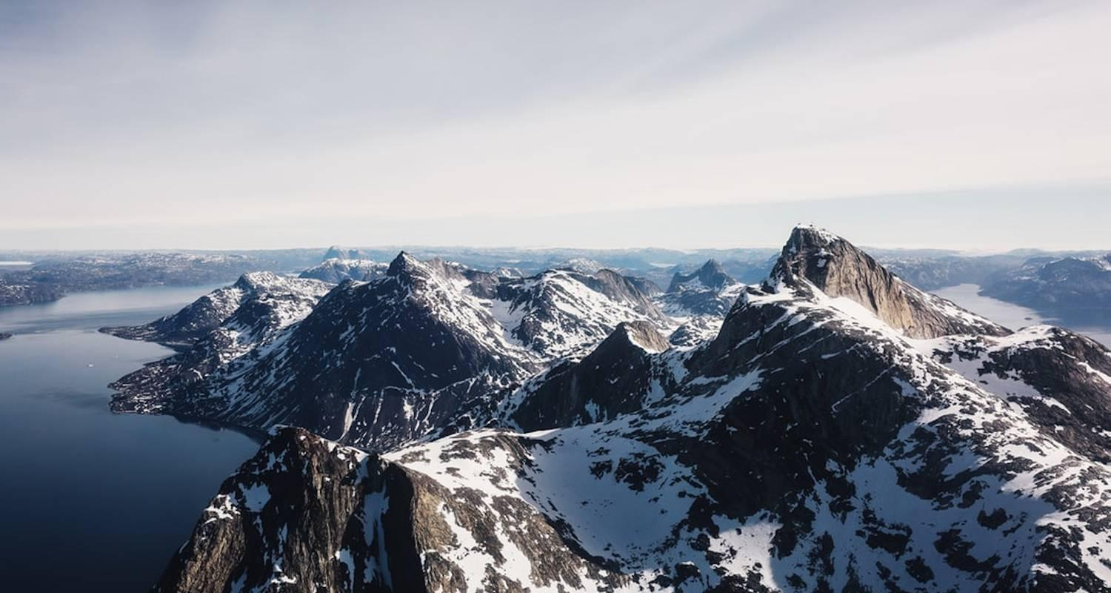

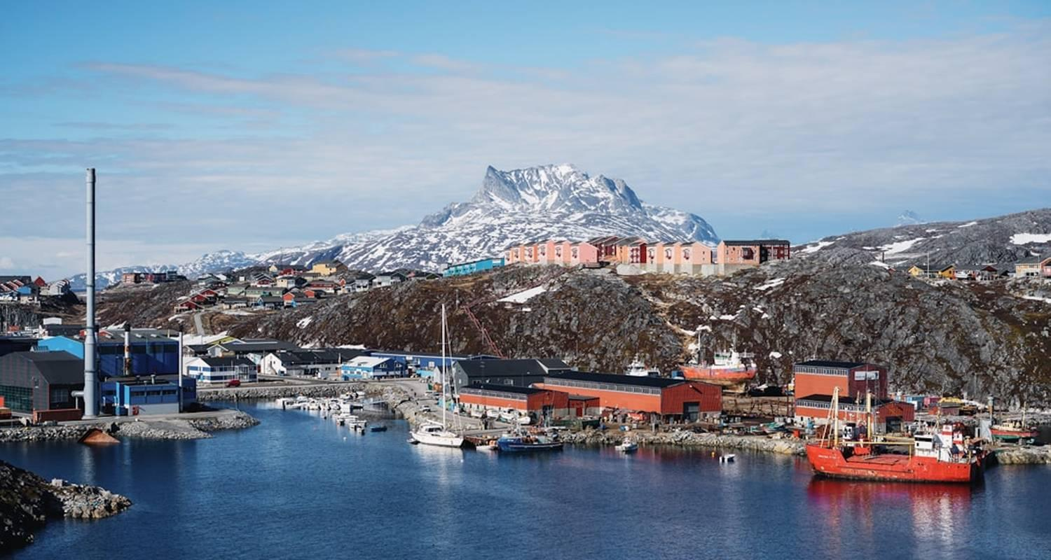

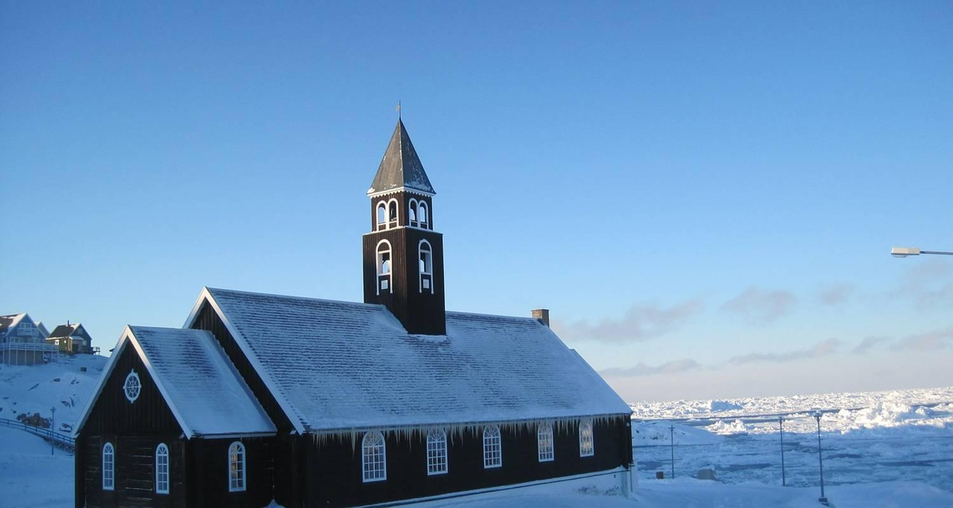







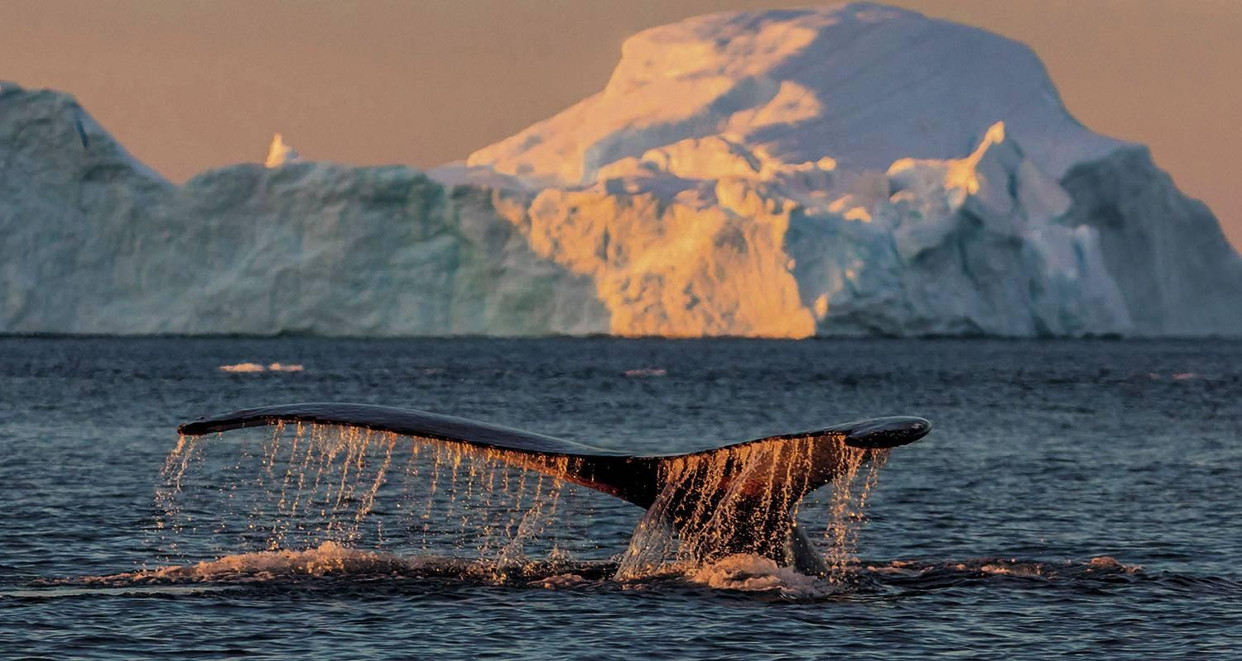

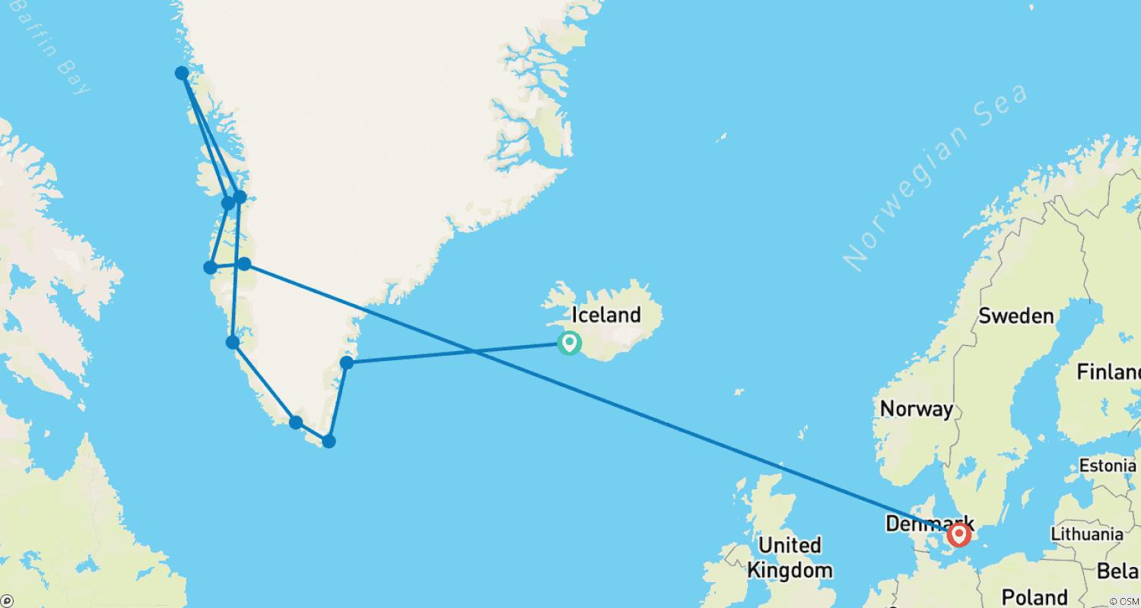

Tour ID: 225230  
Tour Name: 5 Day - Northern Lights, Golden Circle, South Coast, Jökulsárlón & Ice Cave

Tour destinations: ['Reykjavik', 'Thingvellir National Park', 'Geysir', 'Gullfoss', 'Seljaland', 'Vik', 'Kirkjubaejarklaustur', 'Jokulsarlon', 'Skaftafell', 'Fjadrargljufur', 'Reynisfjara', 'Reynisdrangar Cliffs', 'Skogafoss', 'Eyjafjallajokull']

Tour destinations images:

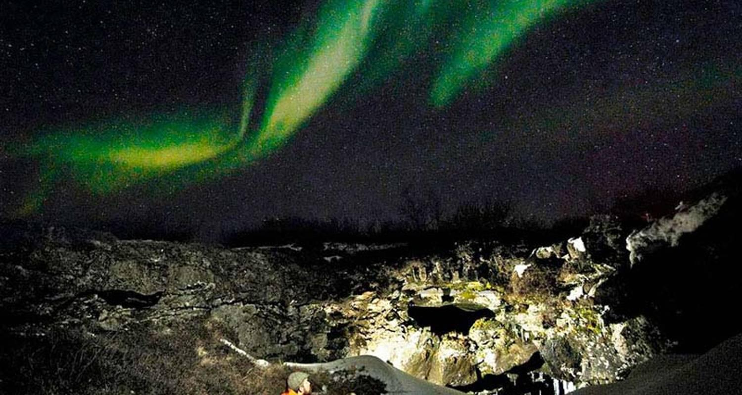

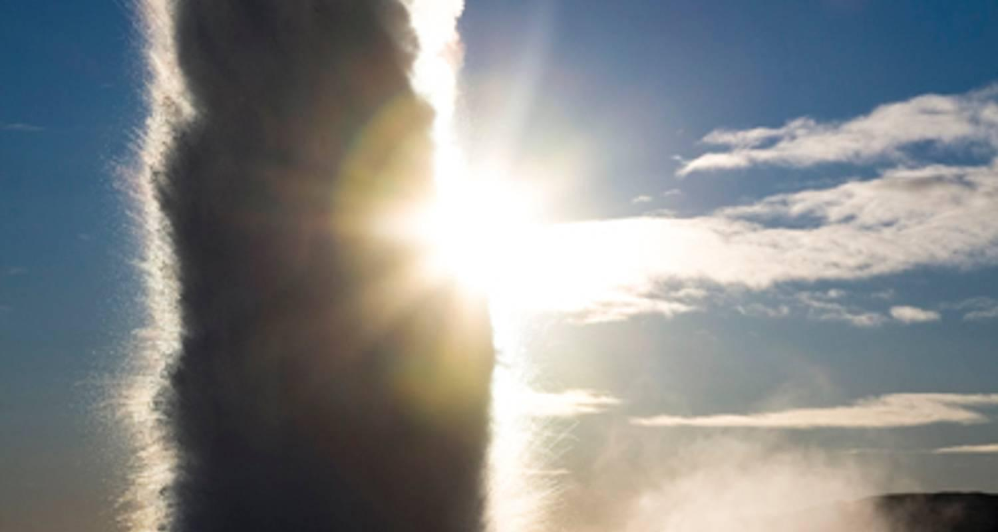

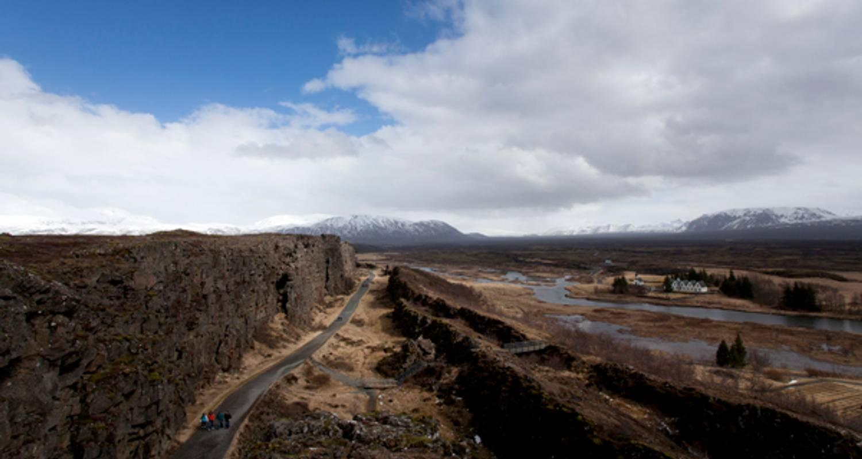

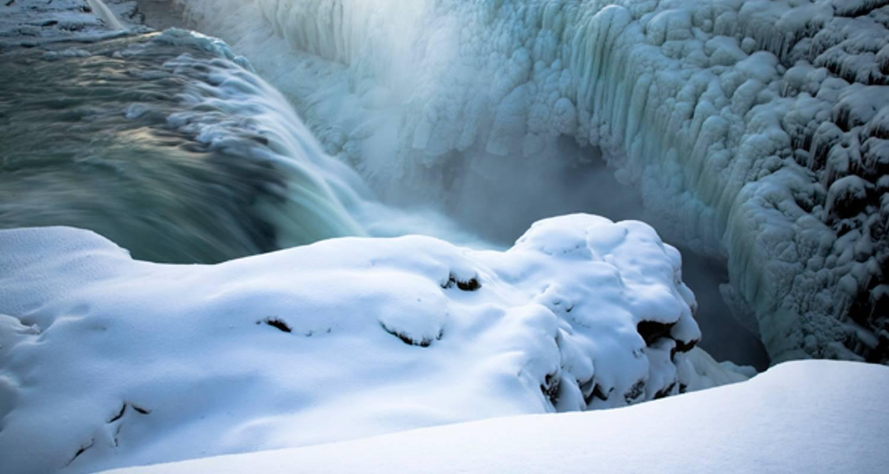

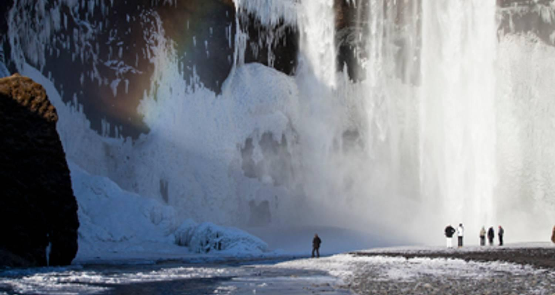

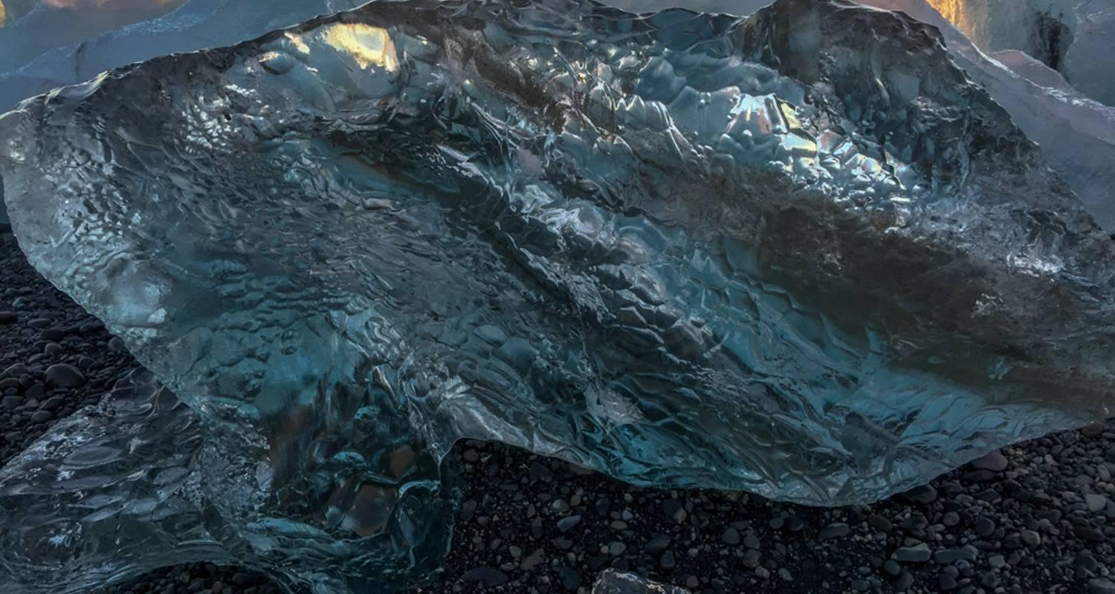

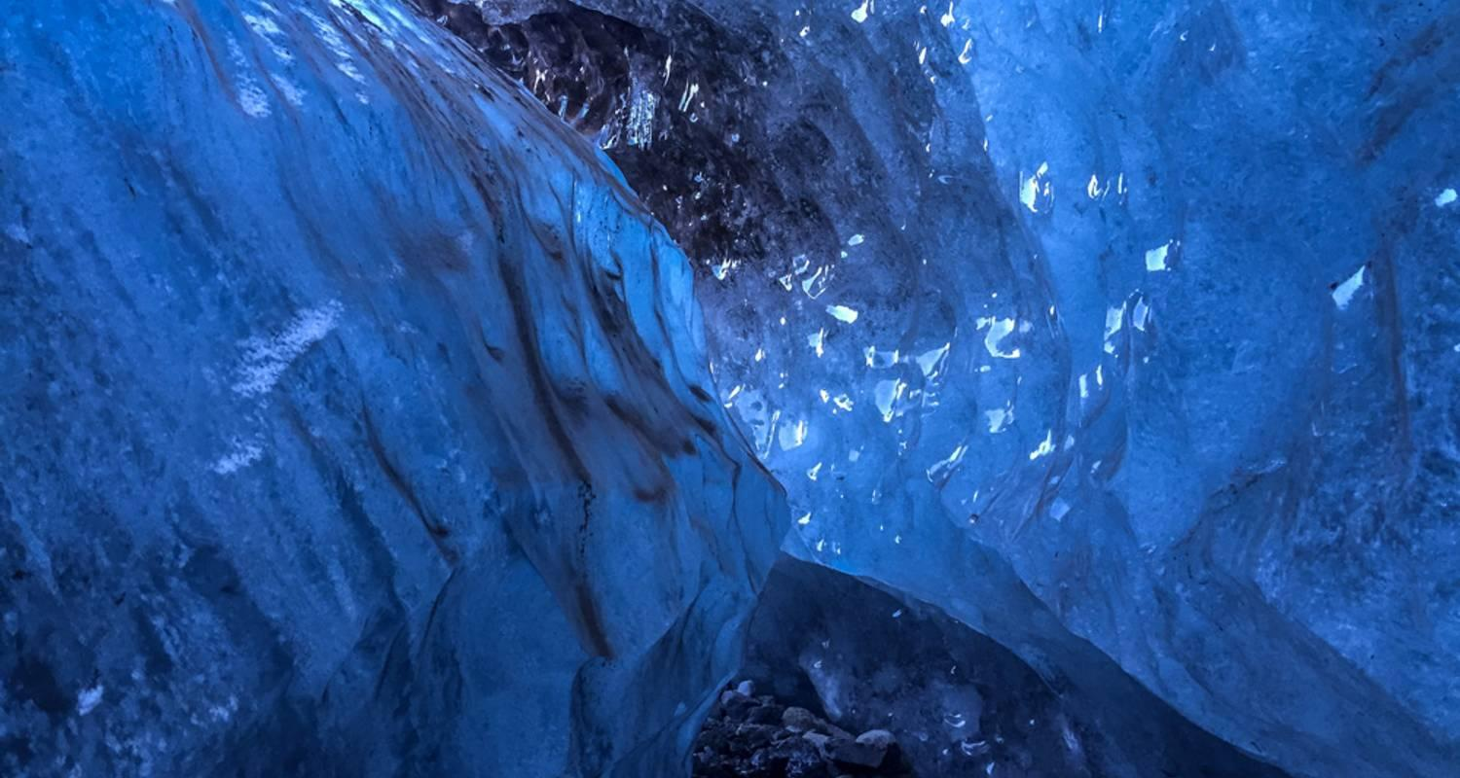

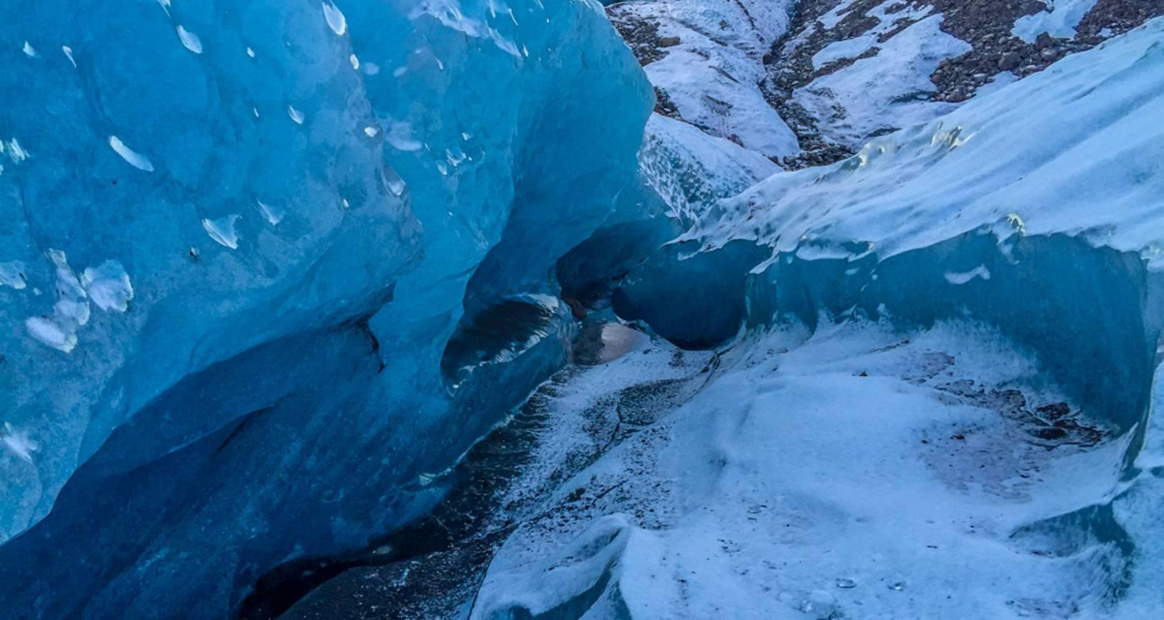

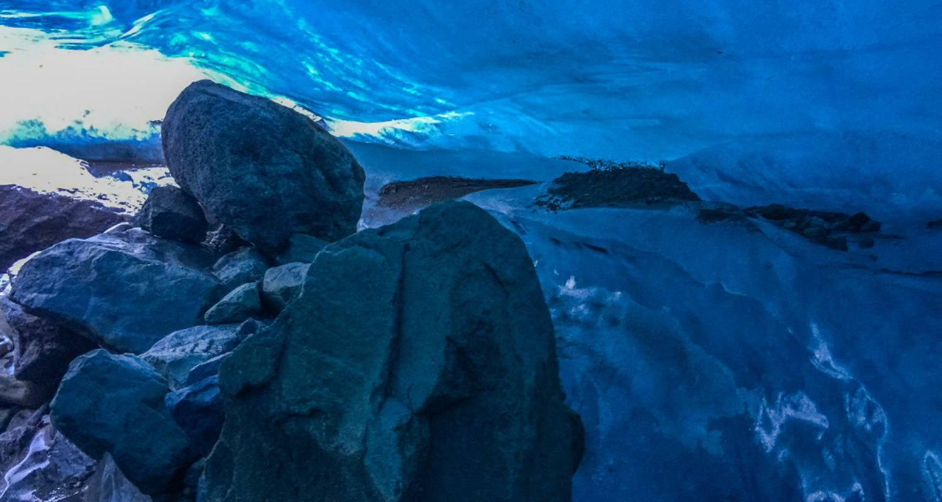

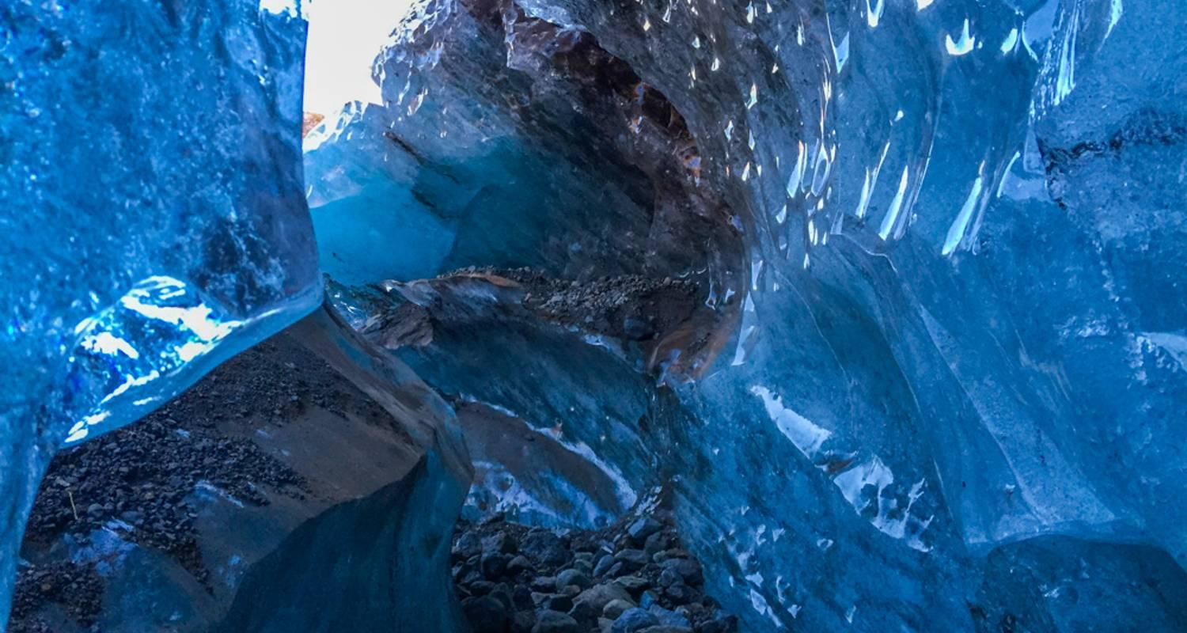

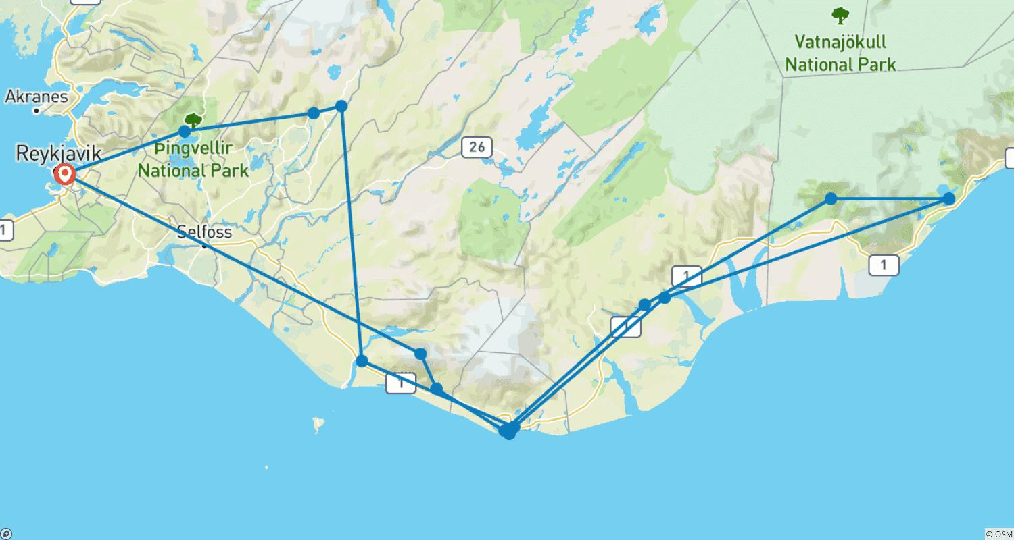

Tour ID: 225568  
Tour Name: Expedition Cruise to Disko Bay- Ocean Albatros

Tour destinations: ['Reykjavik', 'Kangerlussuaq', 'Sisimiut', 'Qeqertarsuaq', 'Uummannaq', 'Ilulissat', 'Sarfannguit']

Tour destinations images:

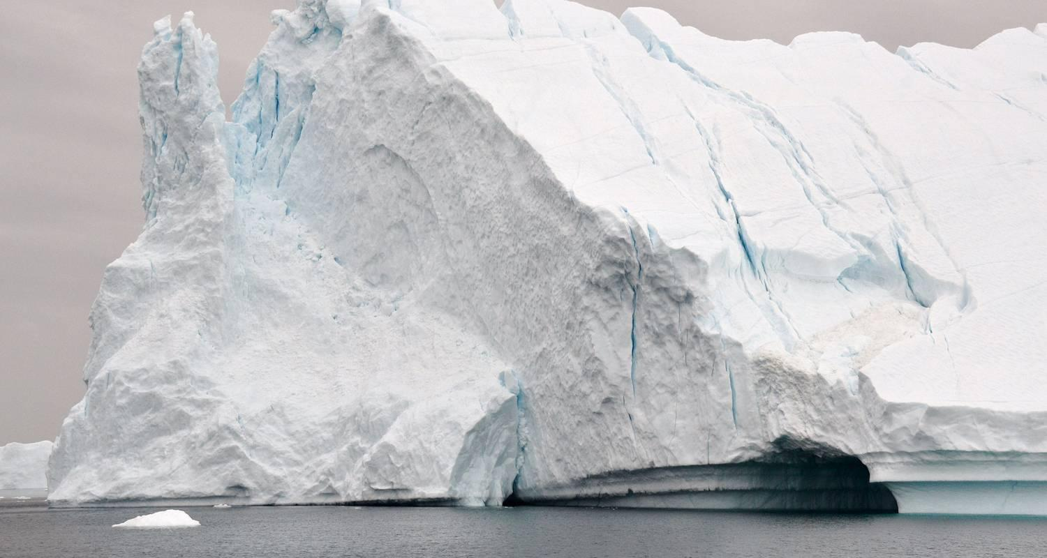

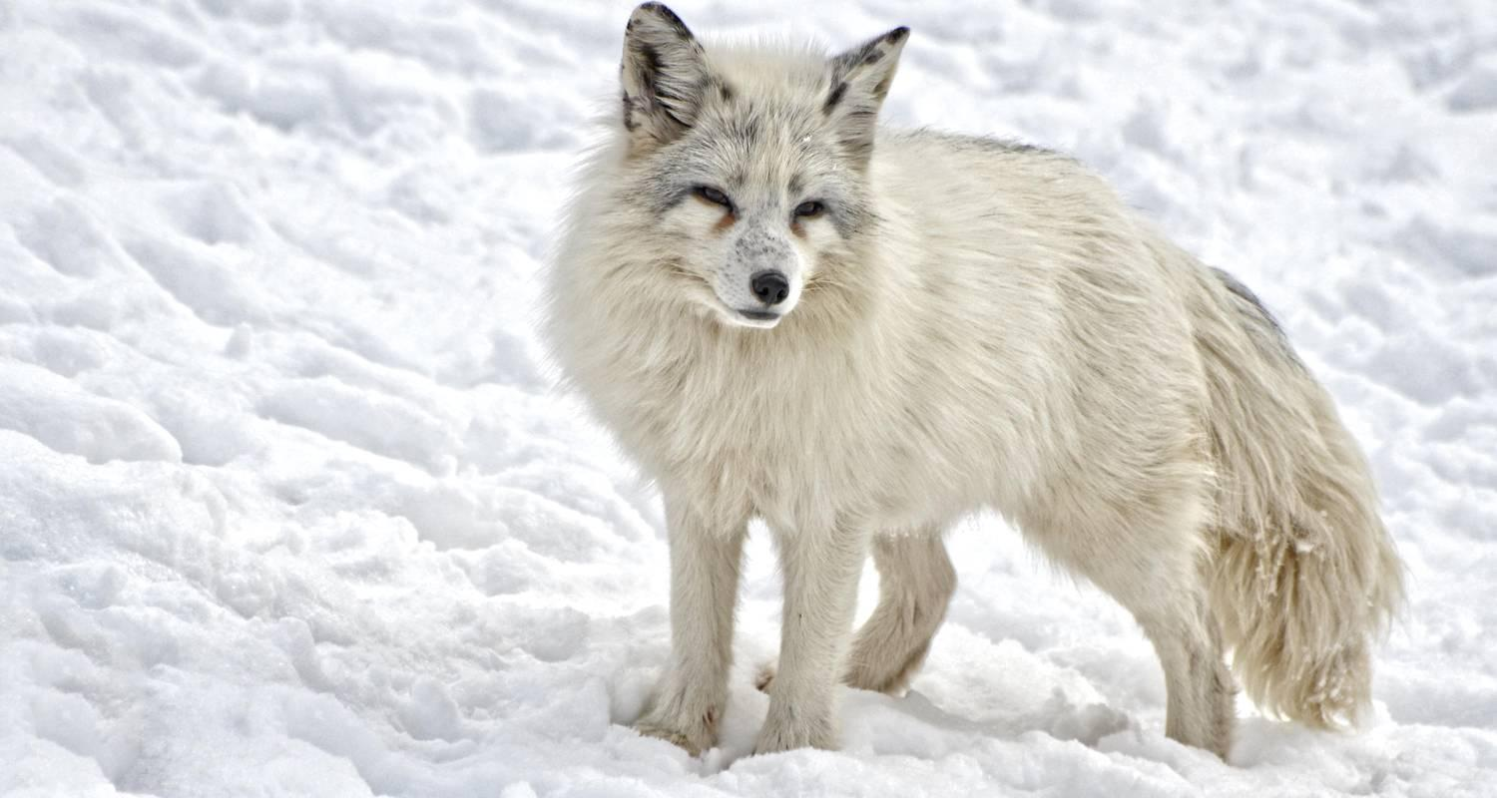

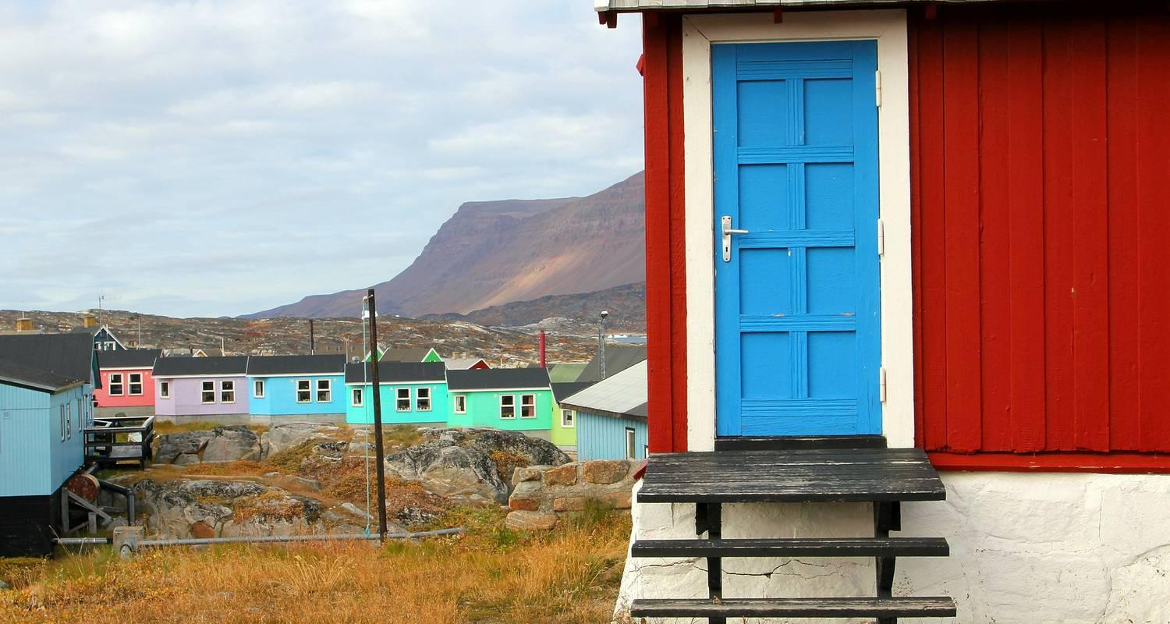

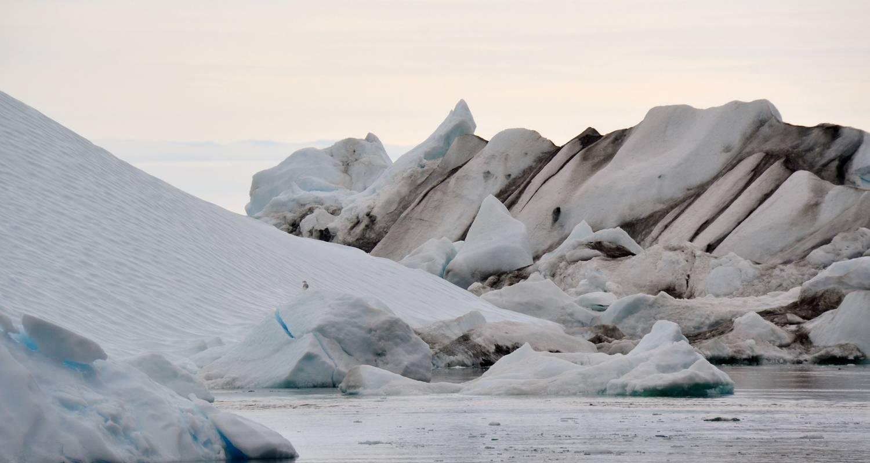

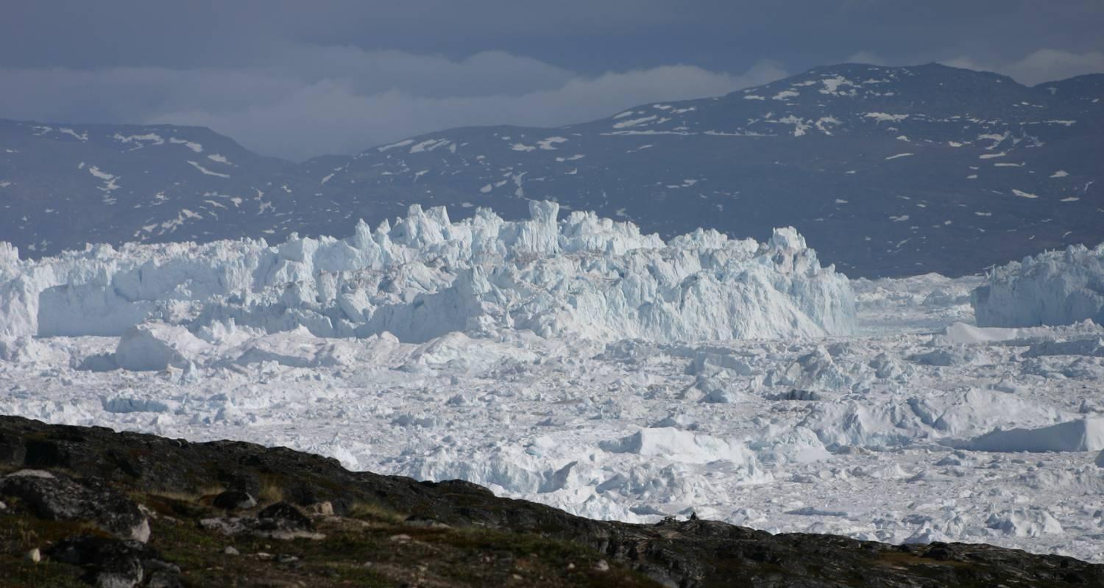

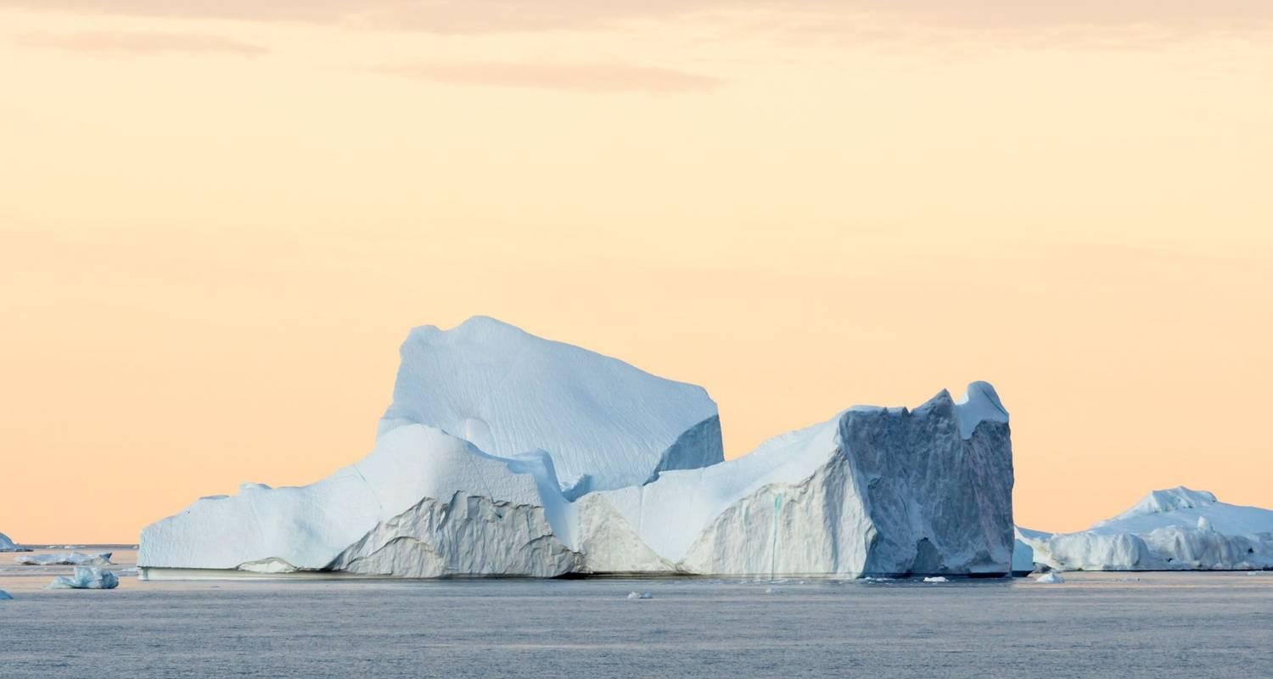

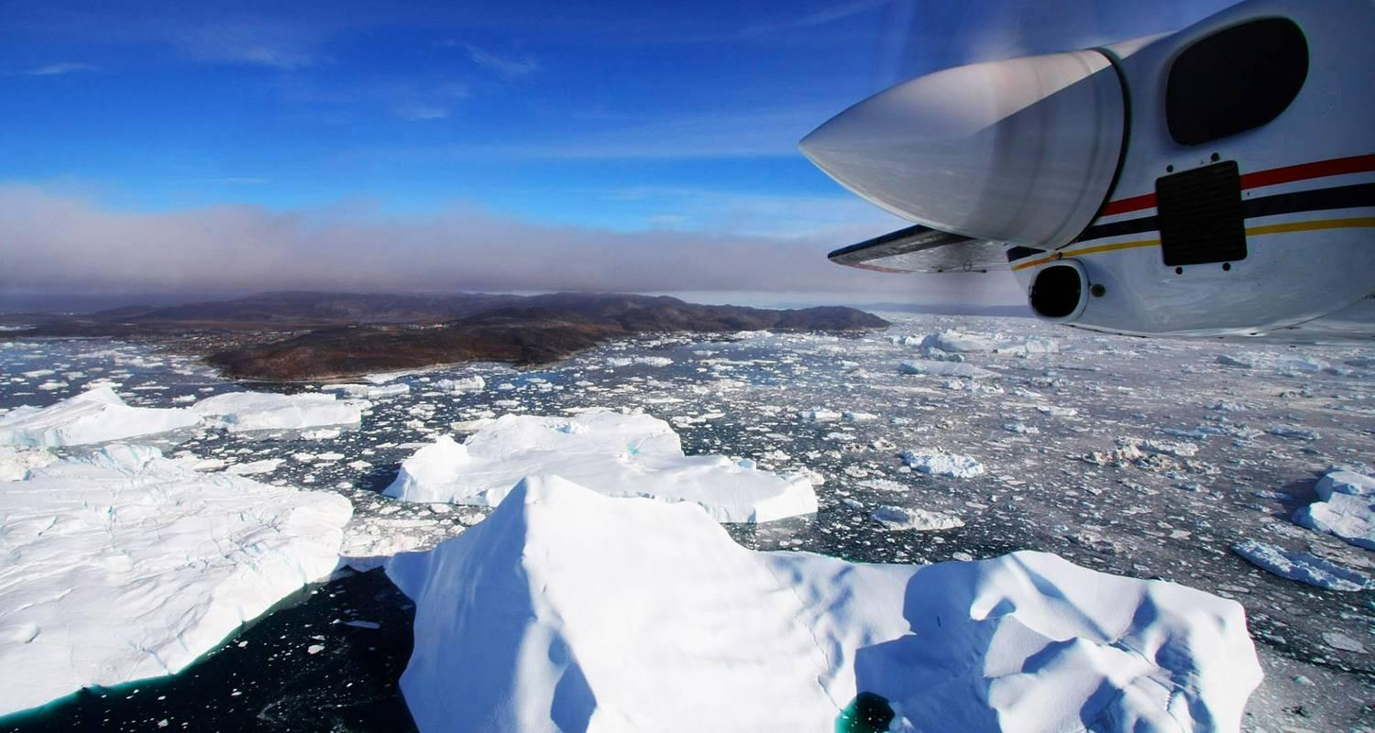

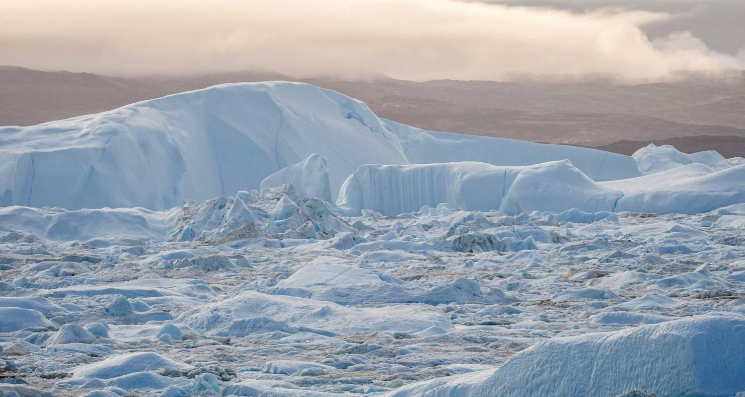

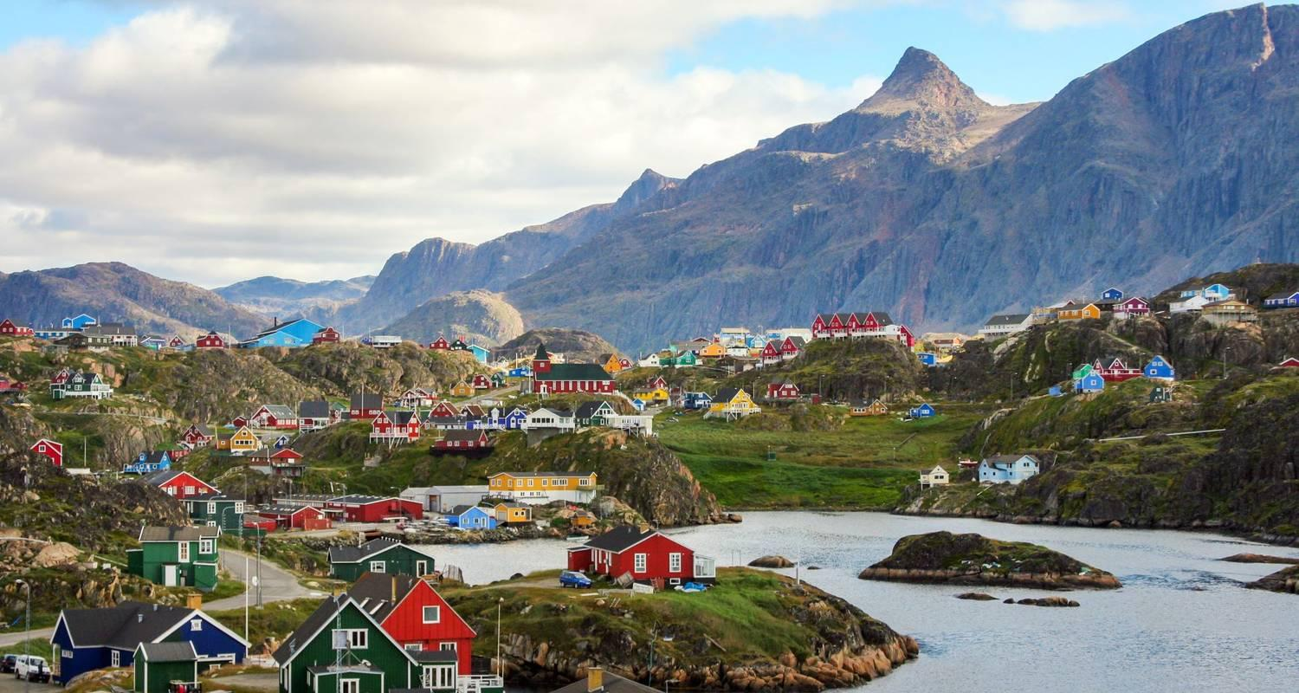

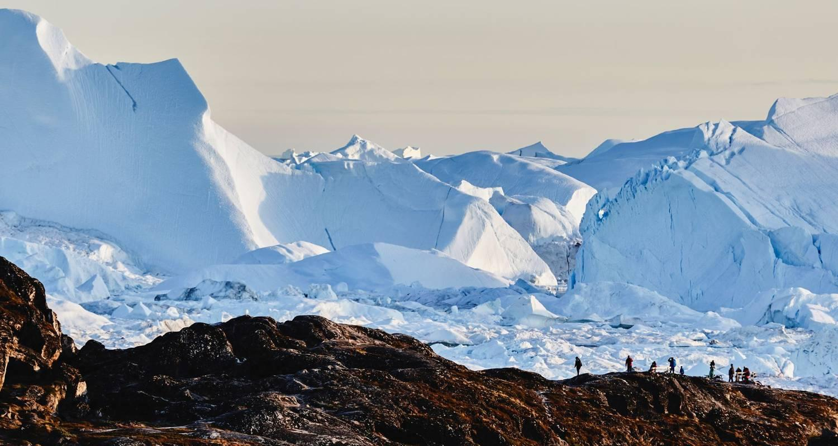

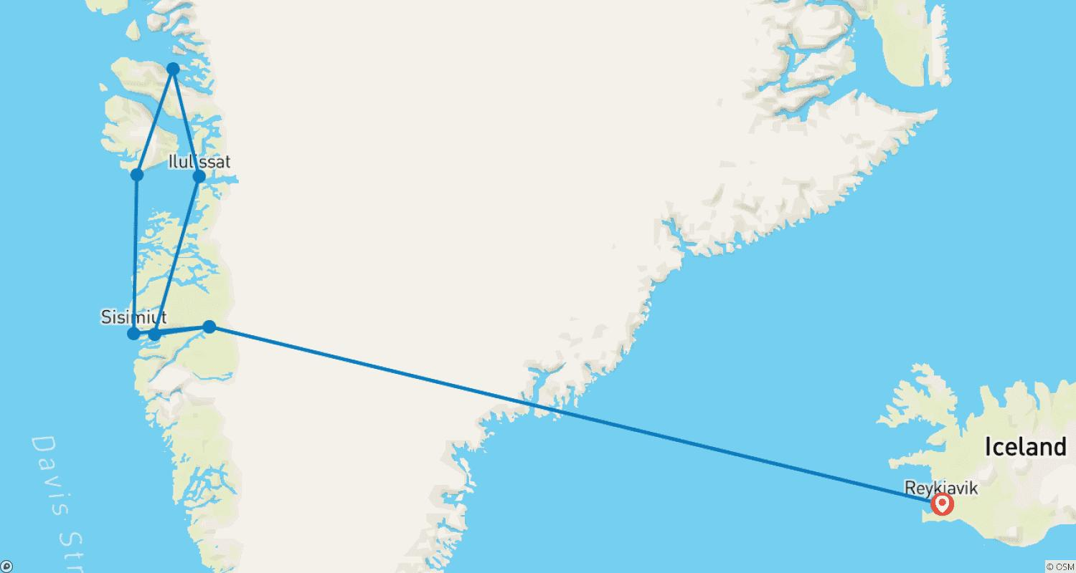

Tour ID: 228308  
Tour Name: South Iceland Summer Explorer - 6 days

Tour destinations: ['Reykjavik', 'Keflavik', 'Blue Lagoon', 'Hella', 'Skogafoss', 'Myrdalsjokull', 'Eyjafjallajokull', 'Vik', 'Reynisfjara', 'Solheimajokull', 'Landmannalaugar']

Tour destinations images:

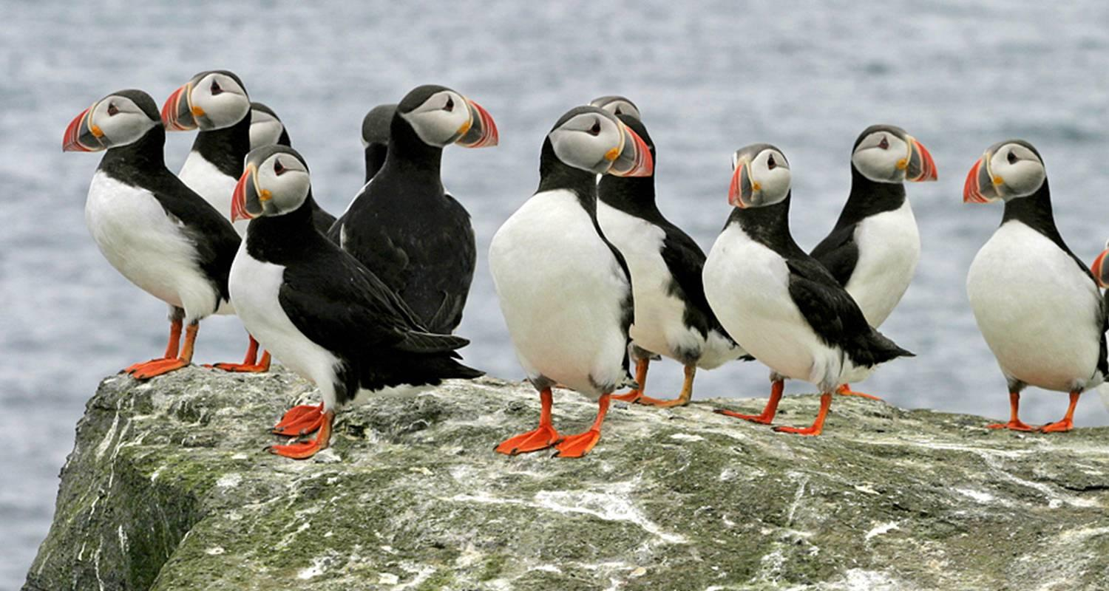

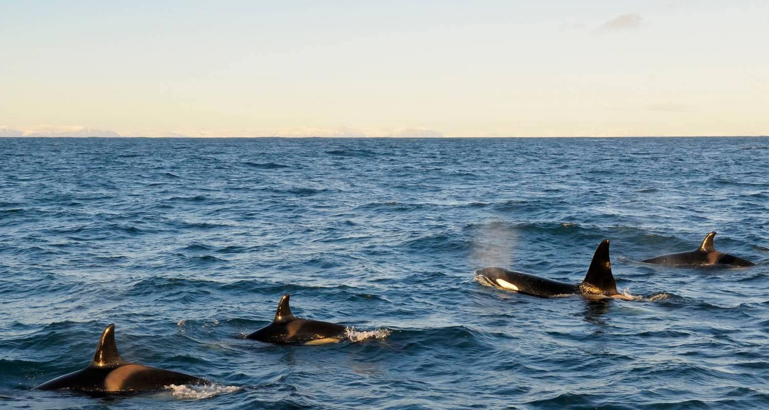

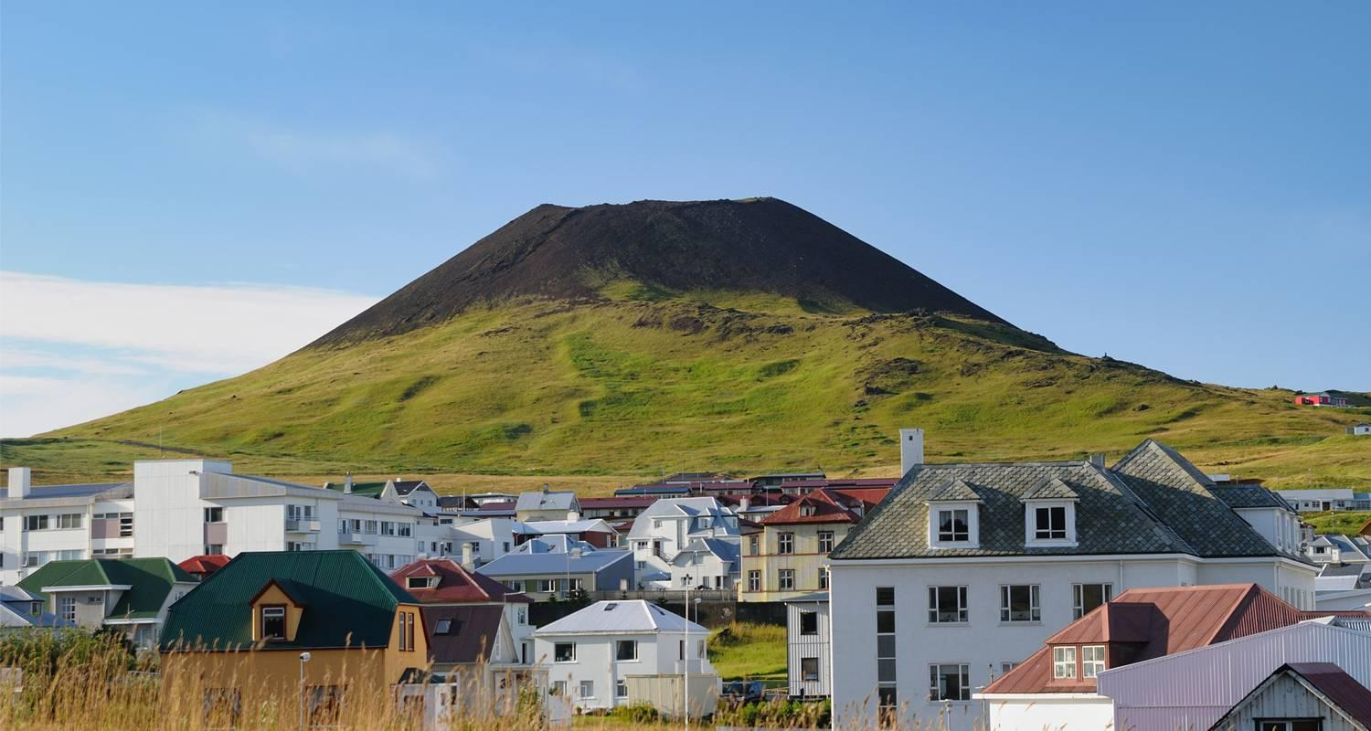

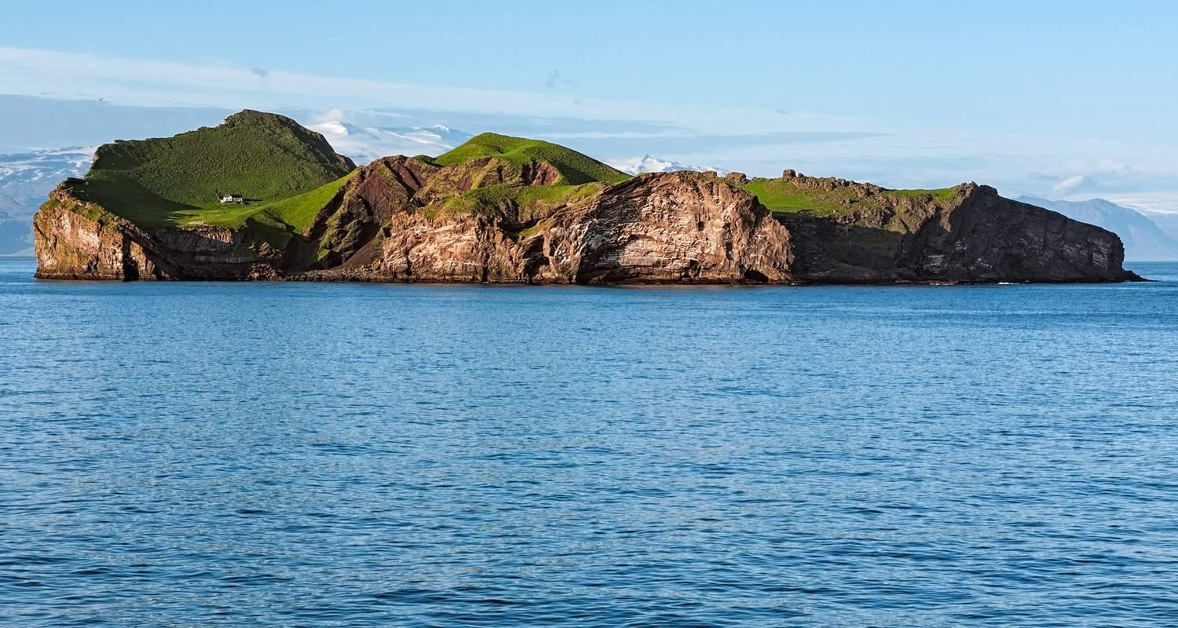

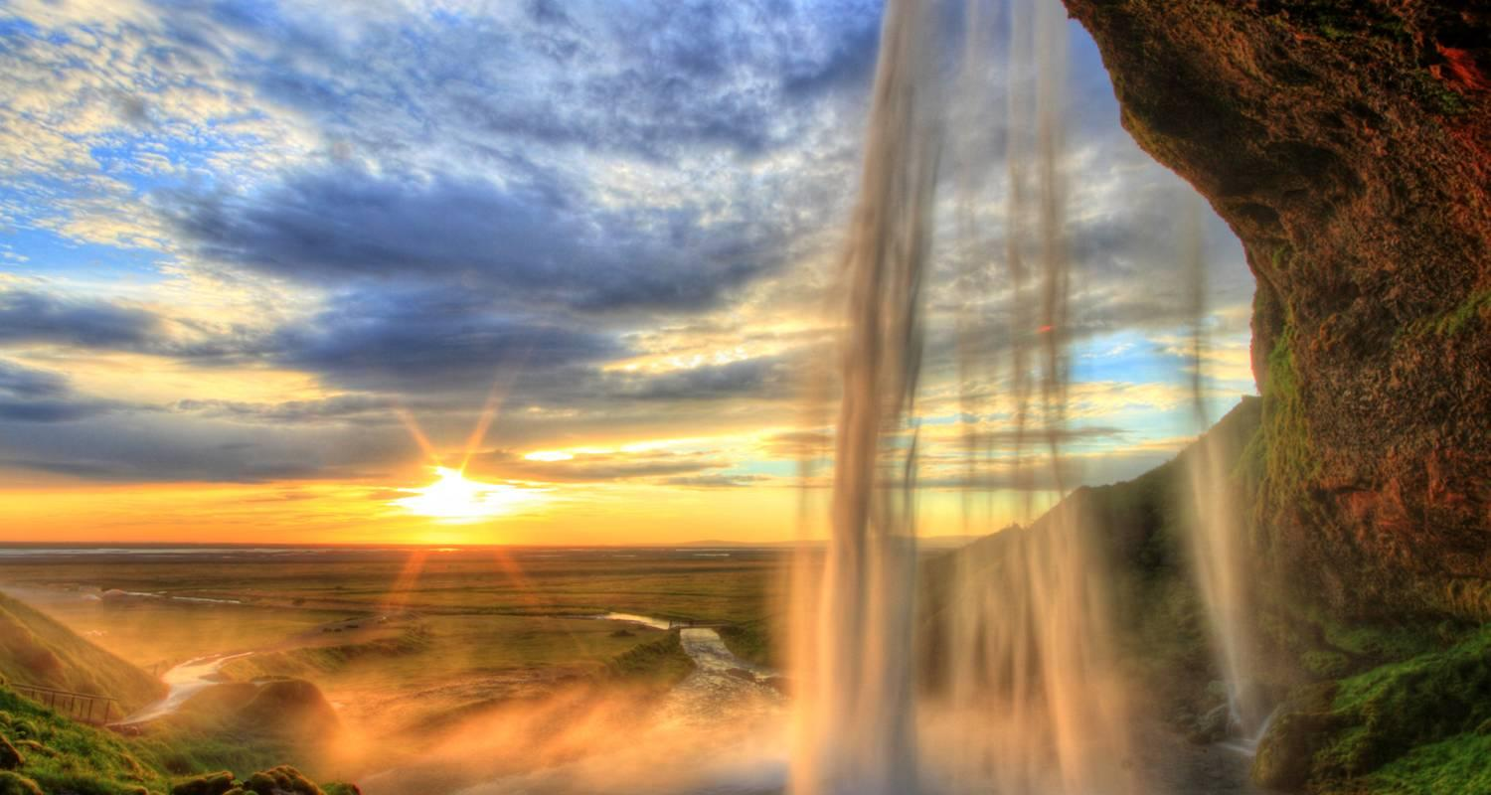

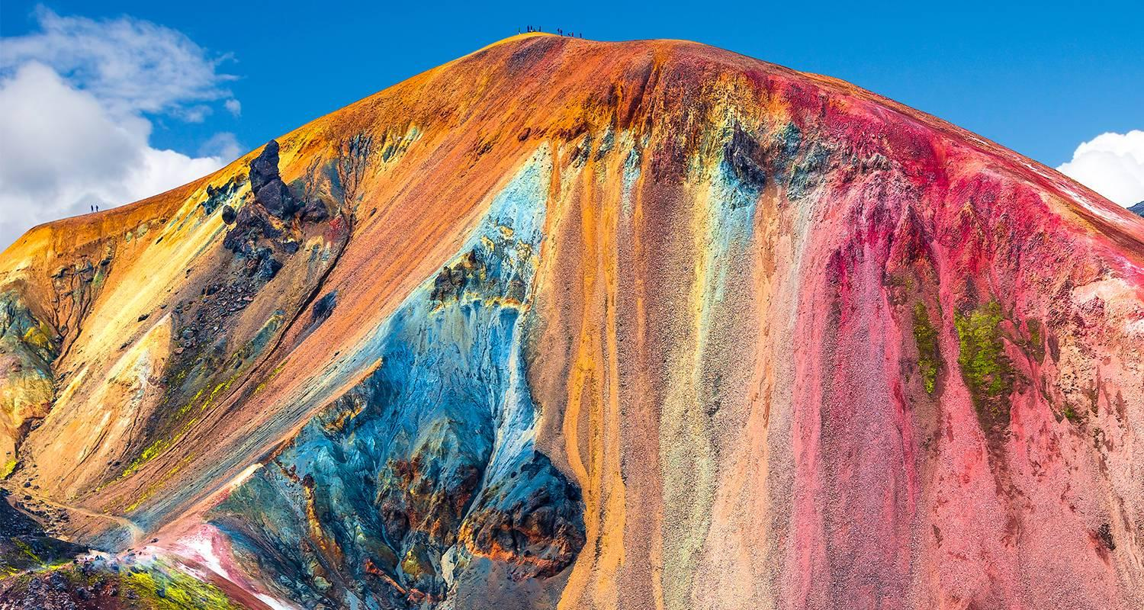

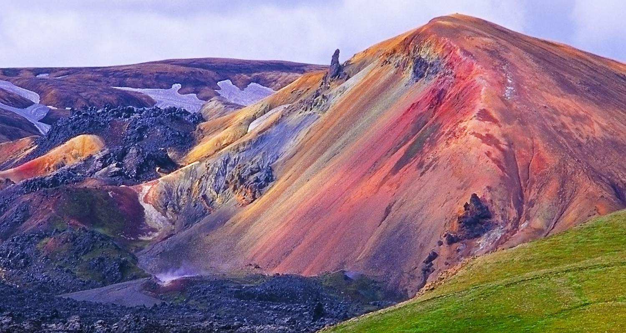

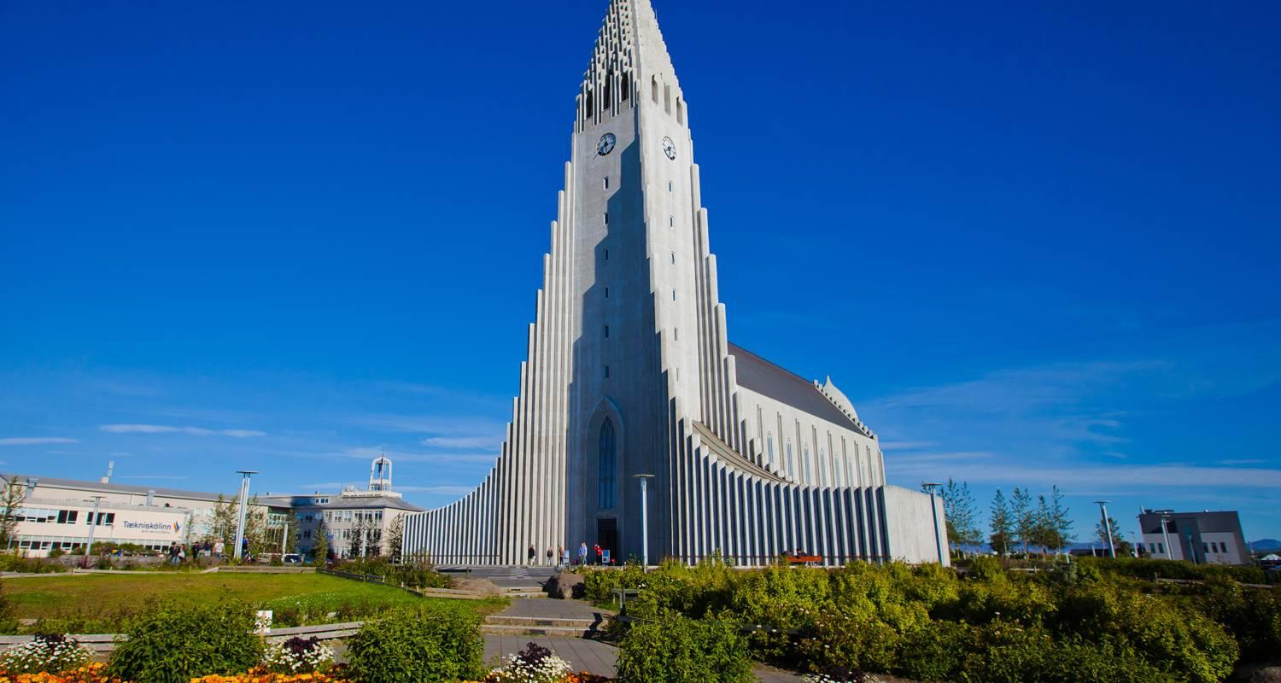

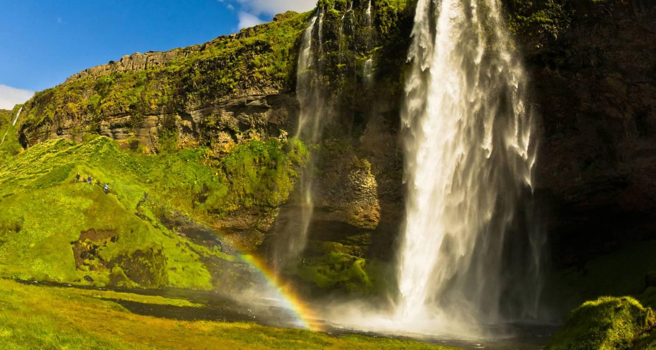

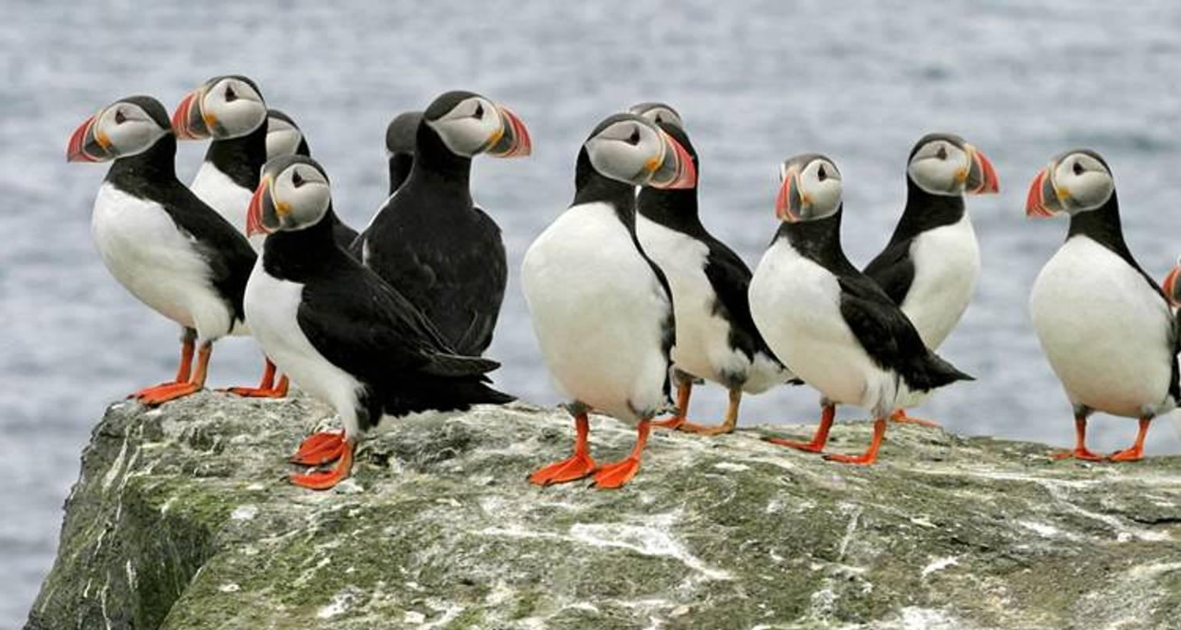

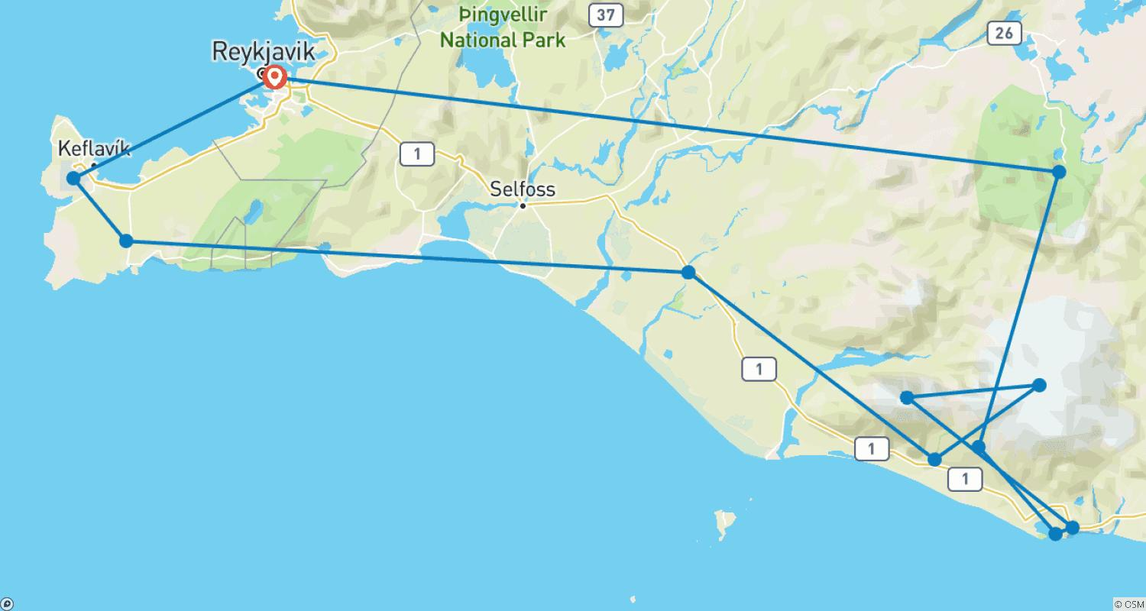

Tour ID: 228351  
Tour Name: South Iceland Summer Express - 3 days

Tour destinations: ['Reykjavik', 'Hella', 'Heimaey Island', 'Seljaland', 'Skogafoss', 'Eyjafjallajokull', 'Myrdalsjokull', 'Vik', 'Reynisfjara', 'Solheimajokull', 'Landmannalaugar']

Tour destinations images:









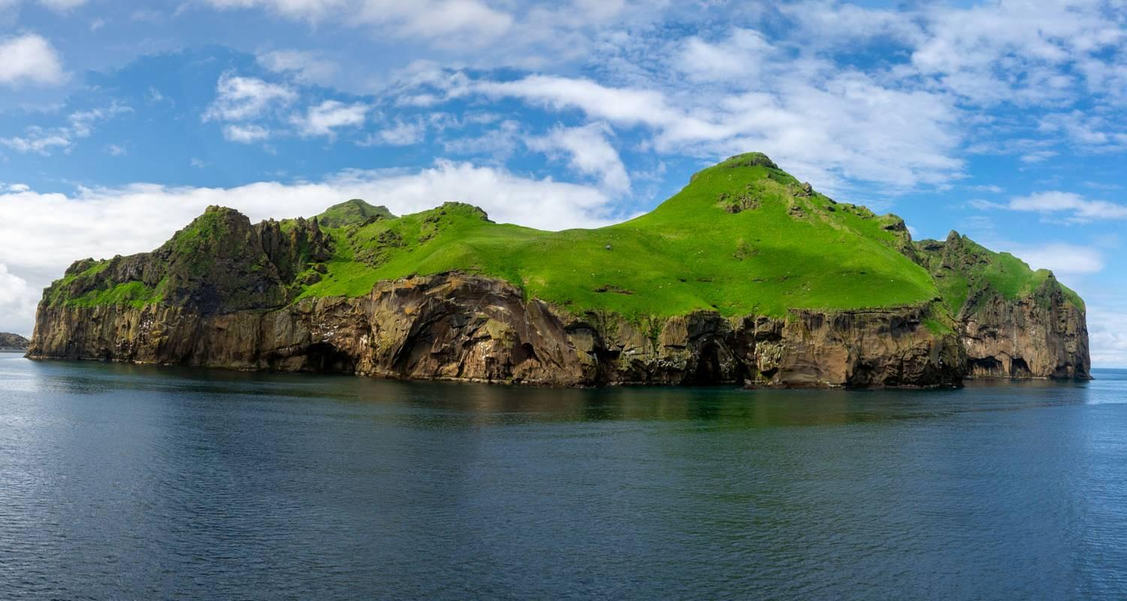

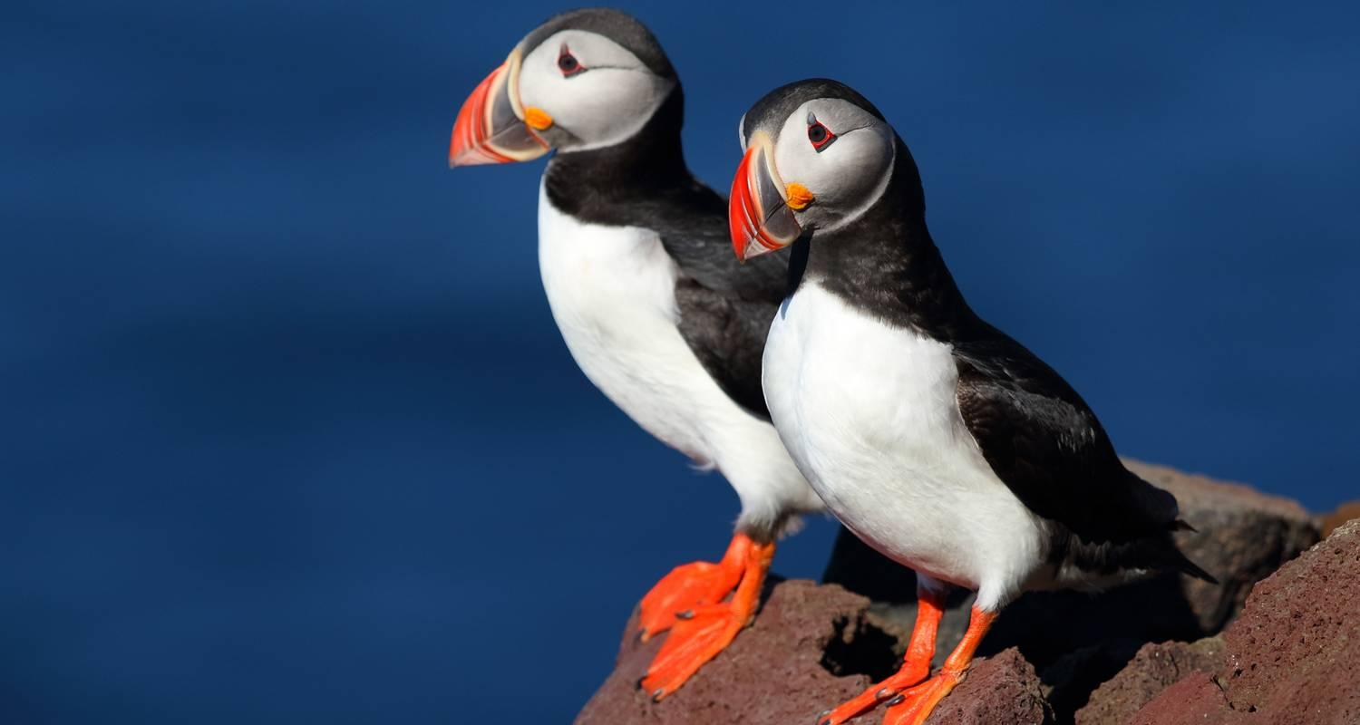

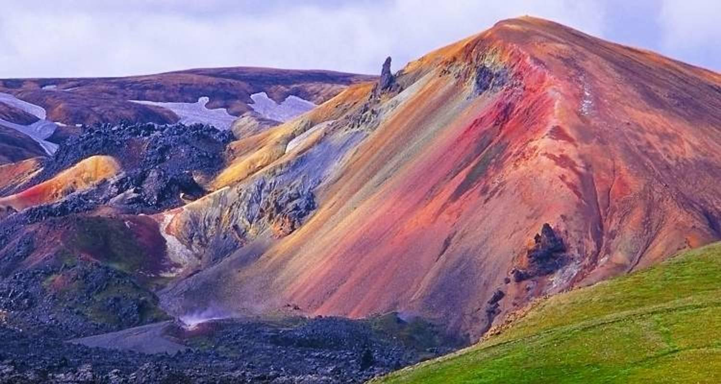

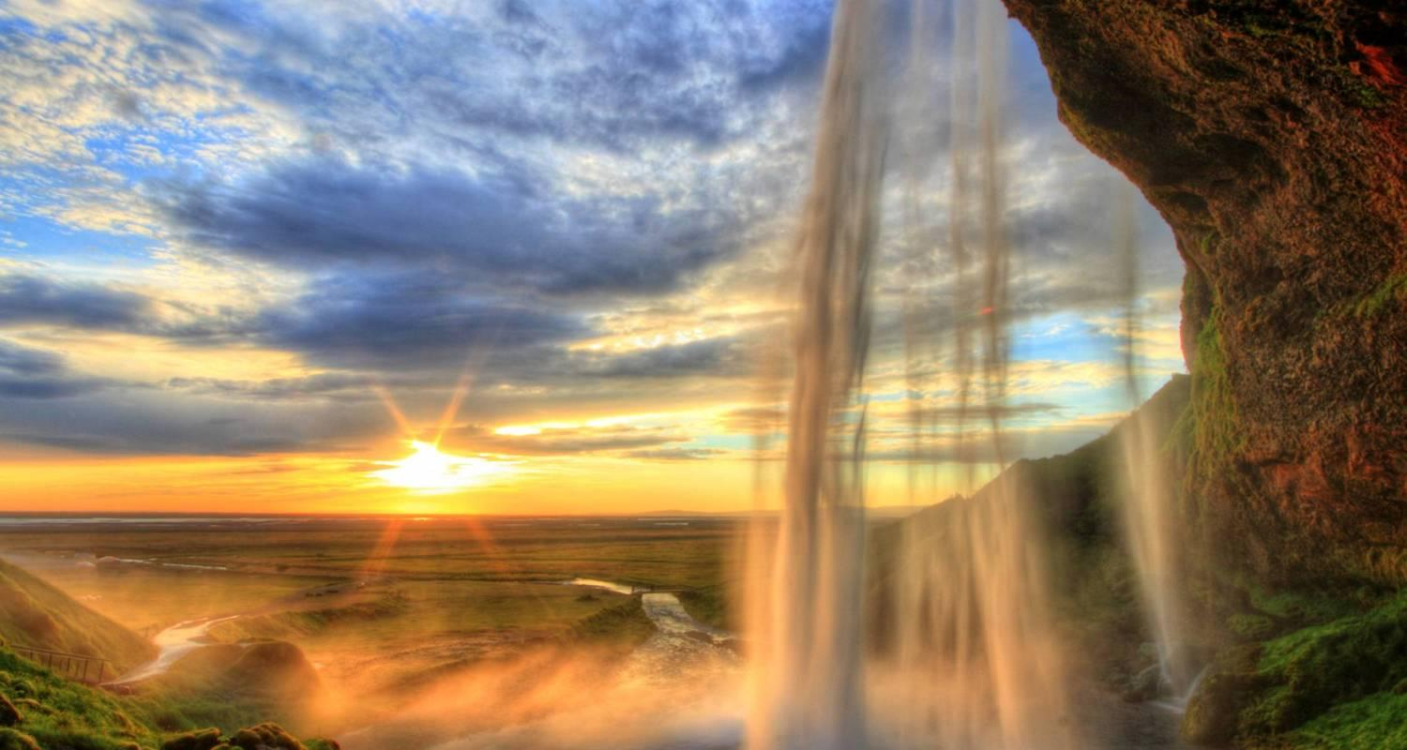

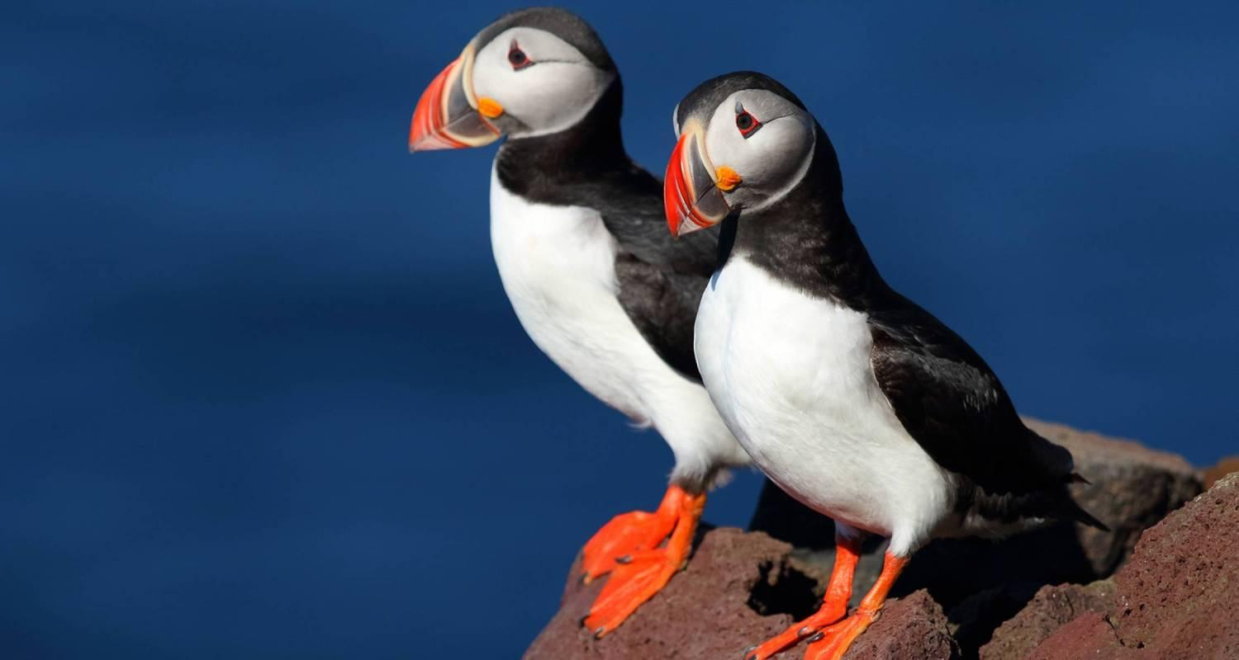

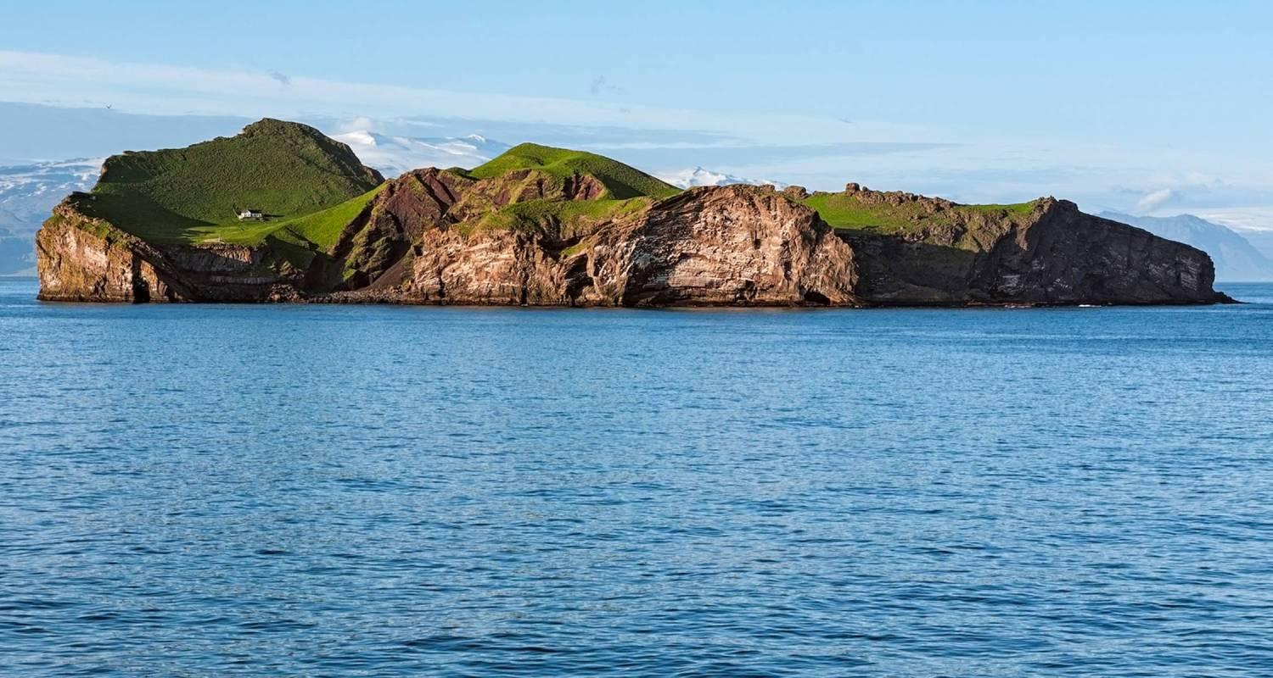

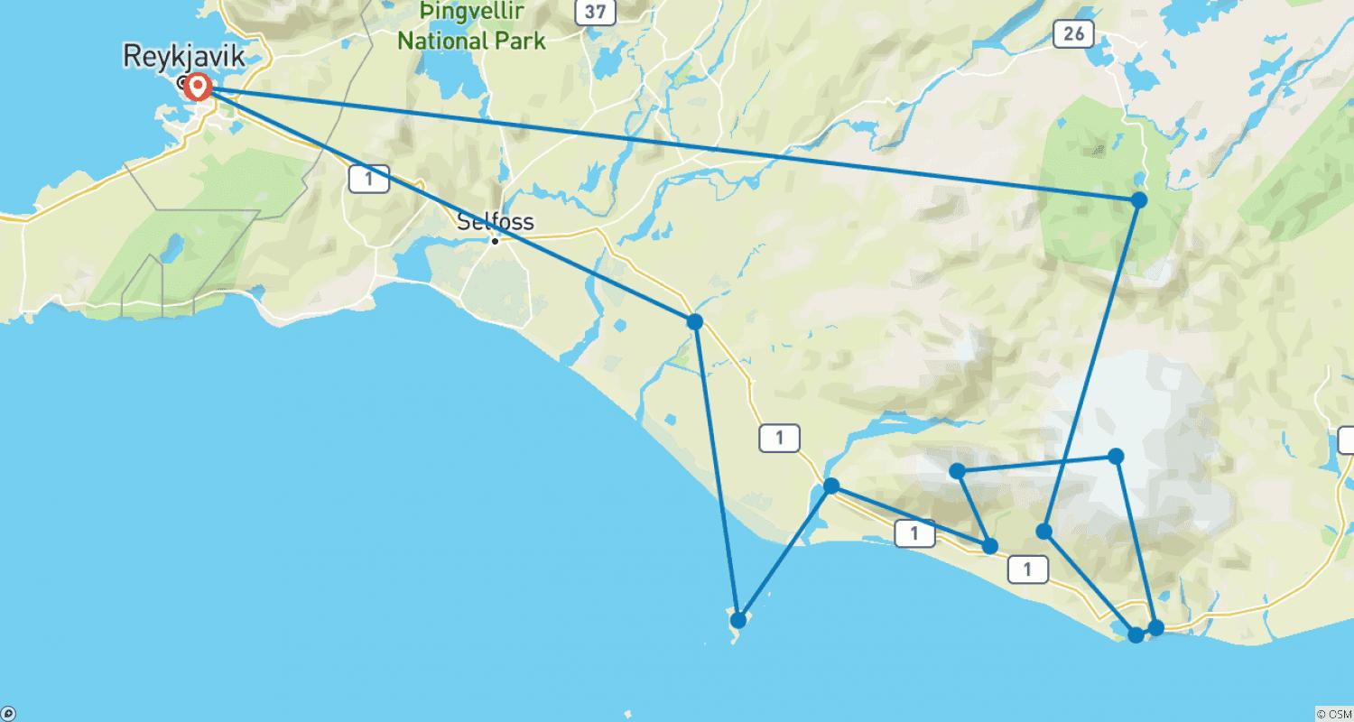

Tour ID: 229477  
Tour Name: Greenland & Iceland Explorer - a cruise & land journey

Tour destinations: ['Reykjavik', 'Borgarnes', 'Hraunfossar', 'Thingvellir National Park', 'Gullfoss', 'Geysir', 'Kirkjubaejarklaustur', 'Blue Lagoon', 'Narsaq', 'Nuuk', 'Ilulissat', 'Upernavik', 'Disko Bay', 'Sisimiut', 'Kangerlussuaq', 'Copenhagen']

Tour destinations images:

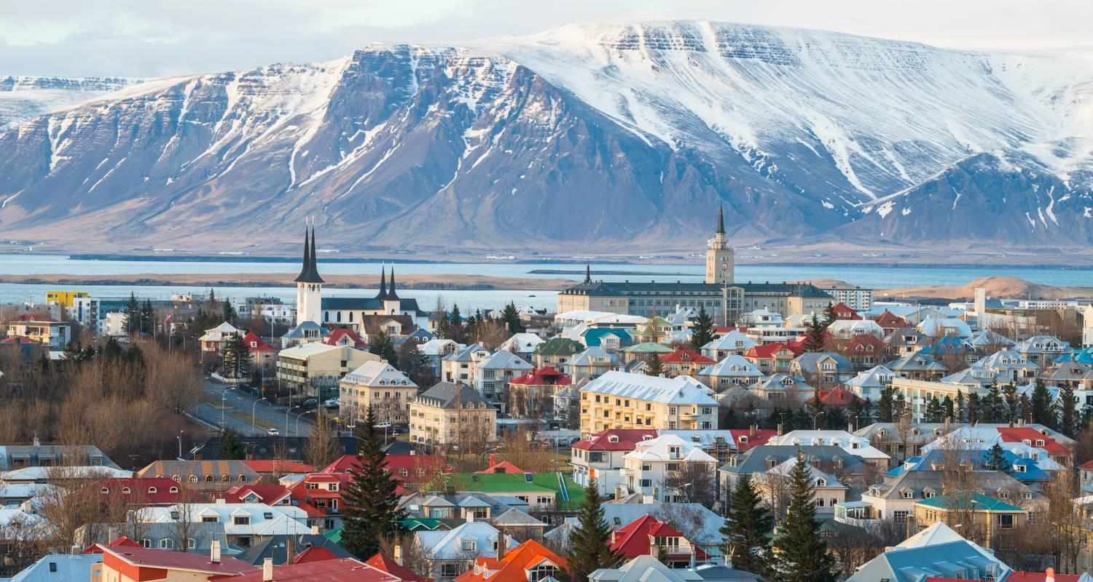

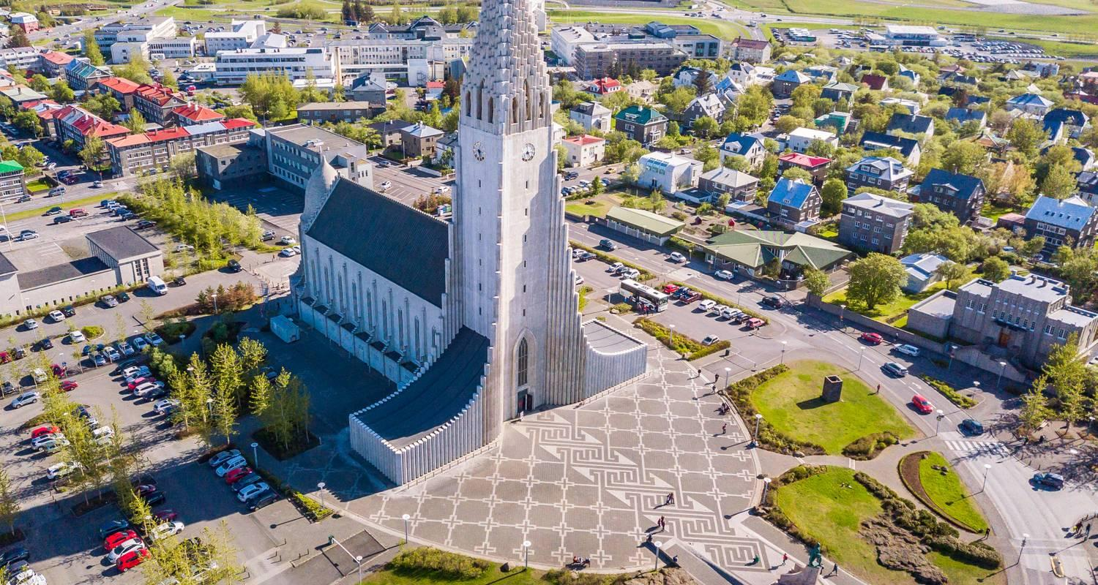

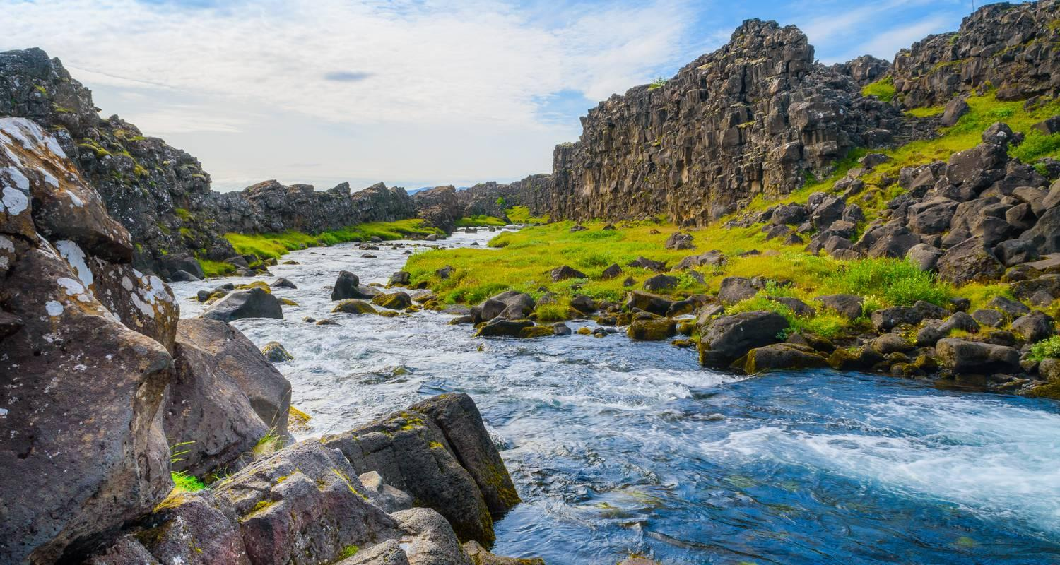

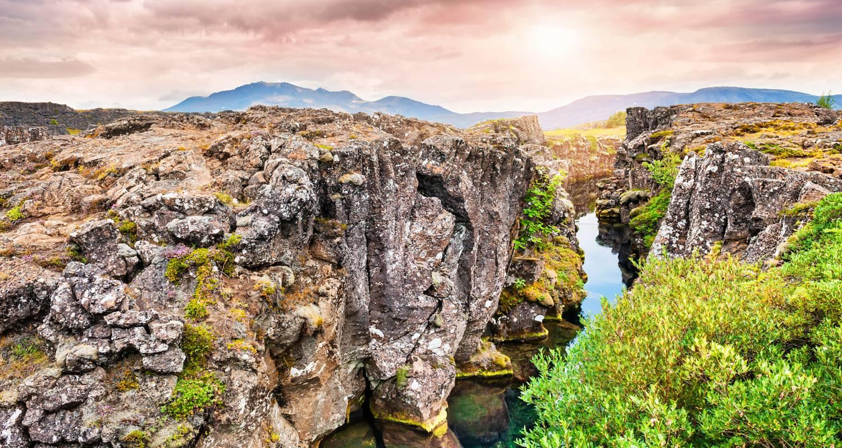

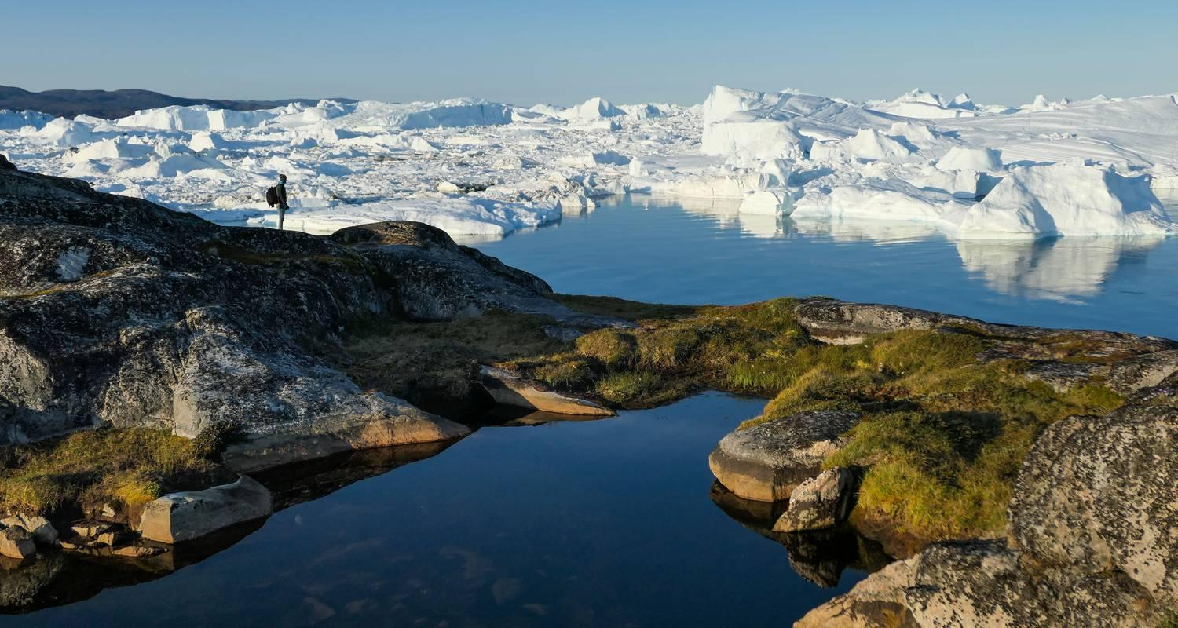

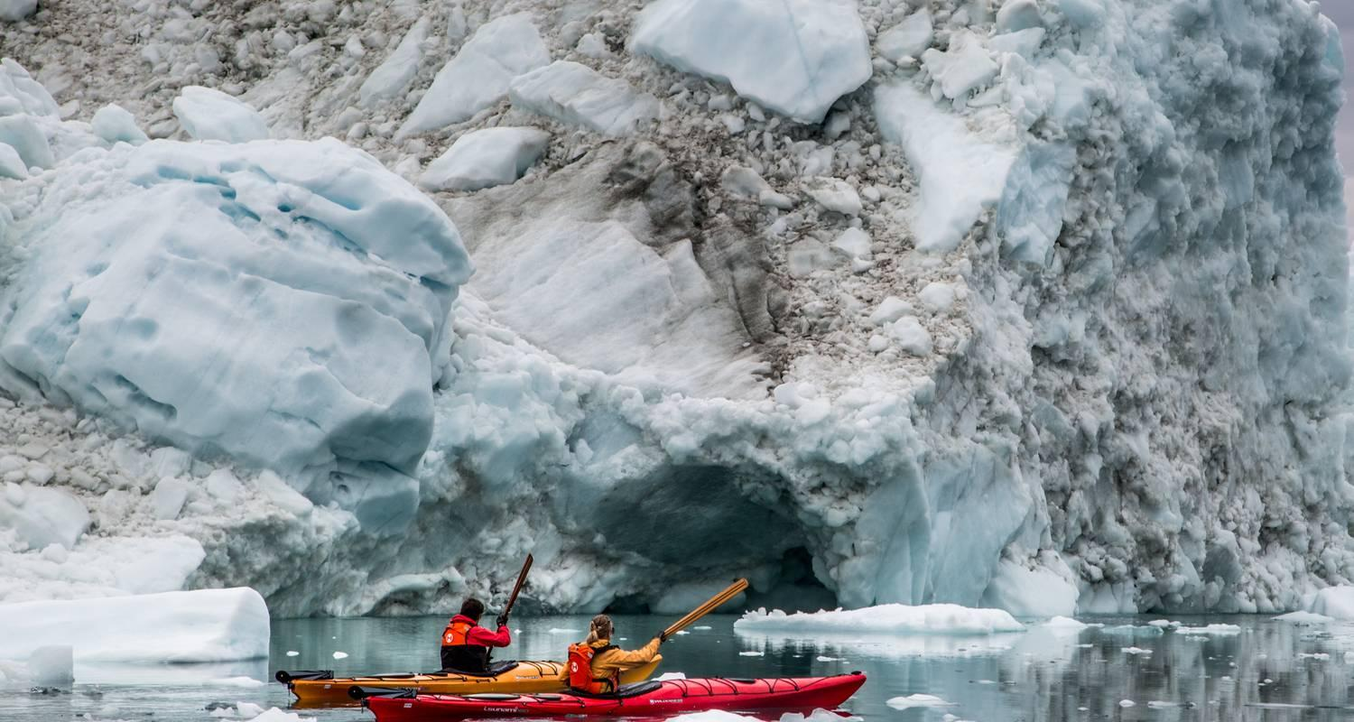

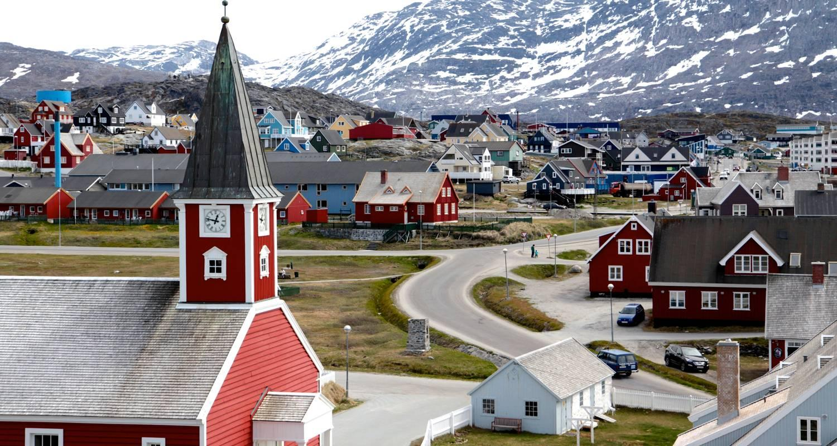

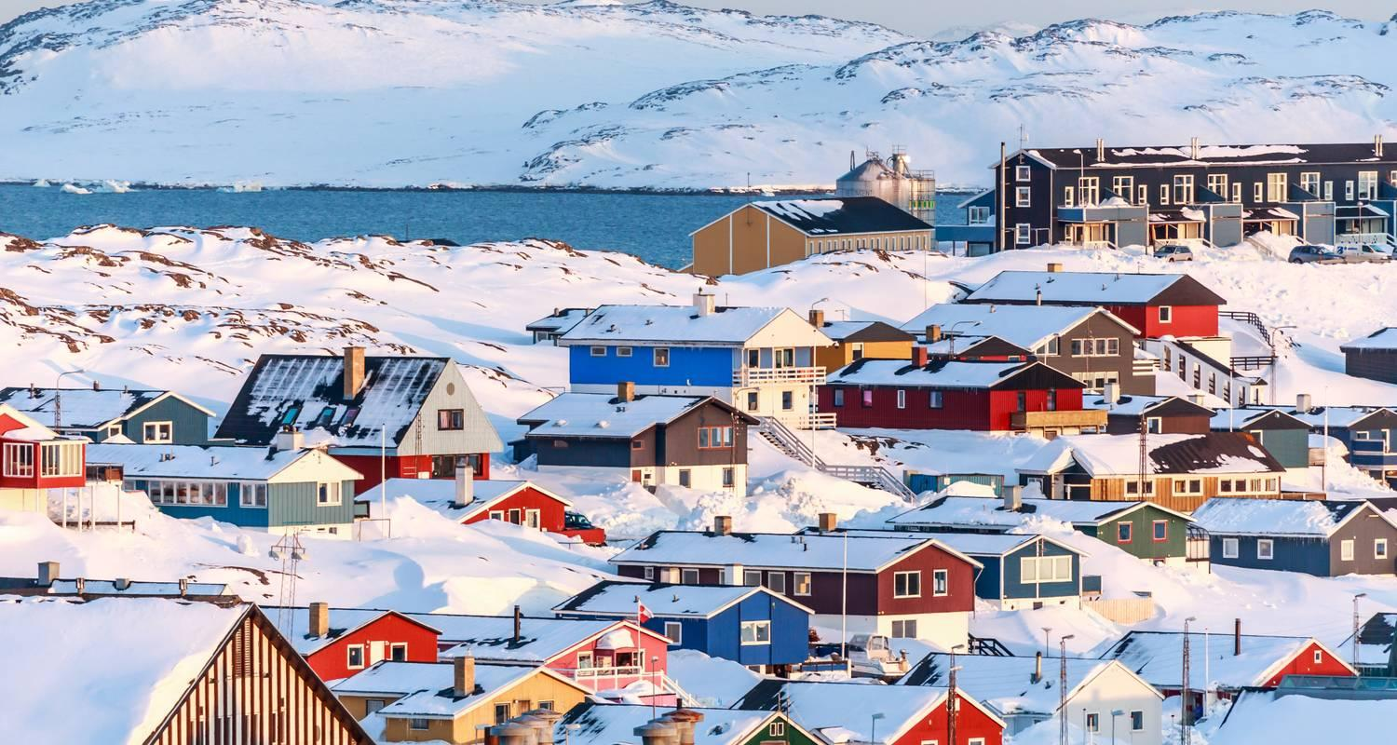

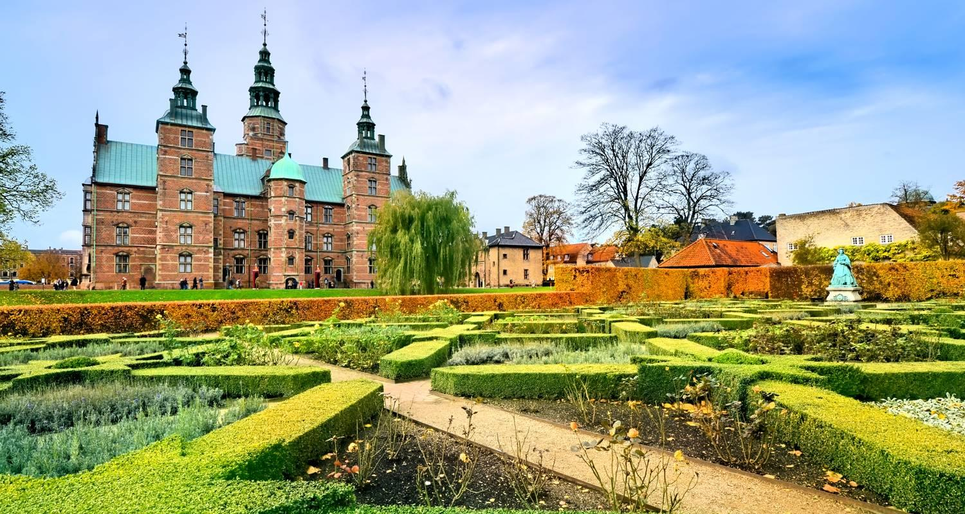

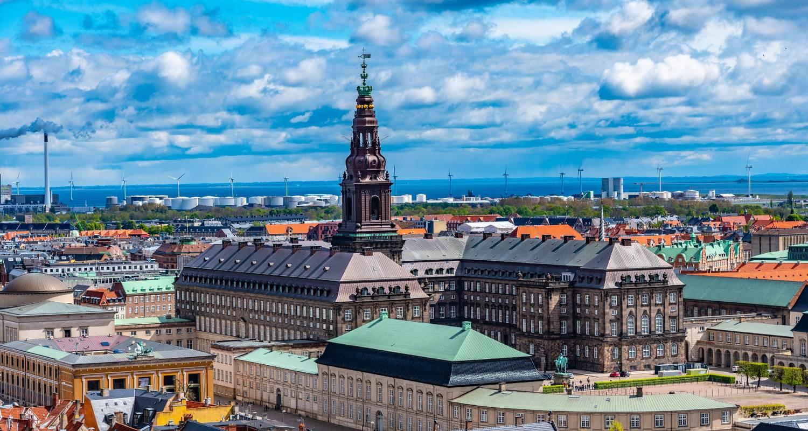

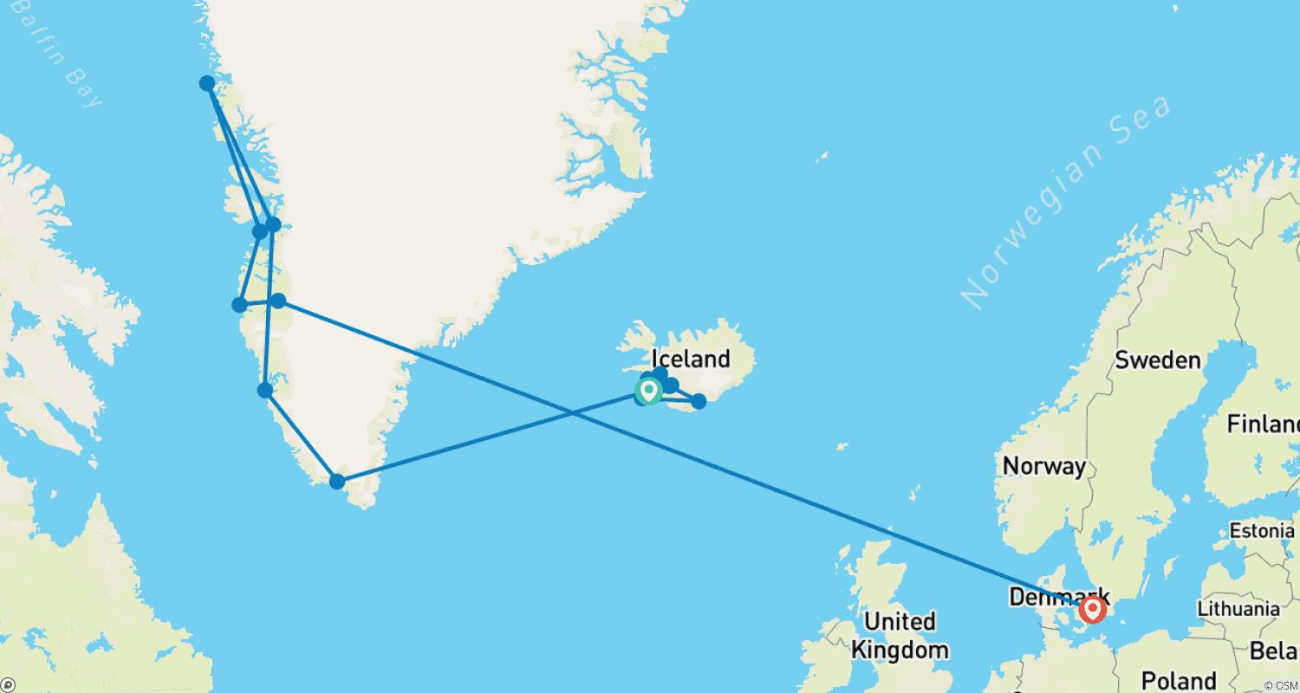

Tour ID: 229481  
Tour Name: Greenland Explorer & Scandinavian Discovery - a cruise & land journey

Tour destinations: ['Reykjavik', 'Skjoldungen', 'Narsaq', 'Nuuk', 'Evighedsfjorden', 'Ilulissat', 'Upernavik', 'Disko Bay', 'Sisimiut', 'Kangerlussuaq', 'Copenhagen', 'Stockholm', 'Oslo', 'Lofthus', 'Bergen']

Tour destinations images:







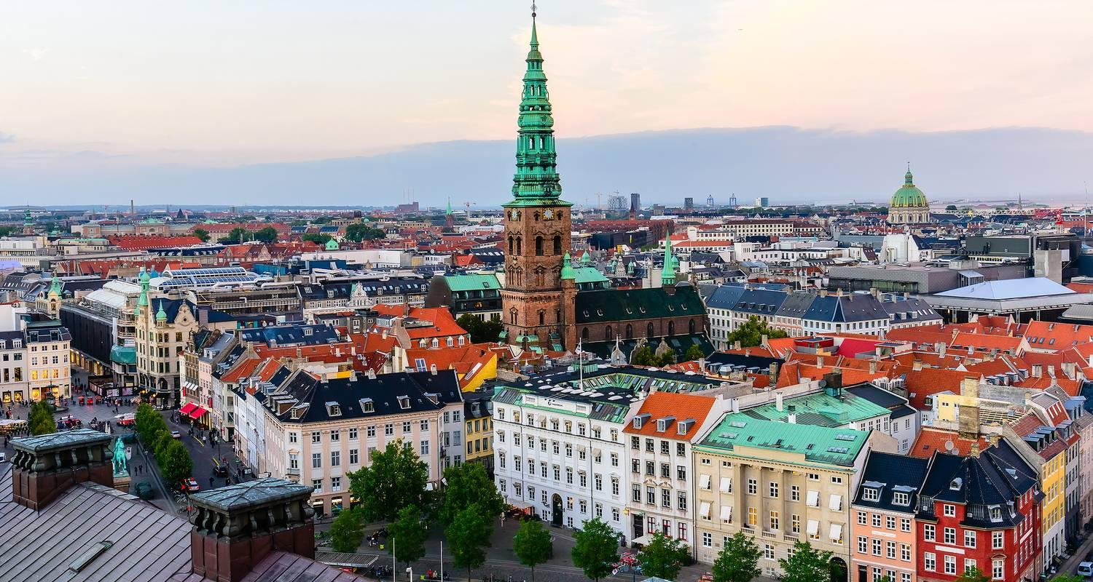

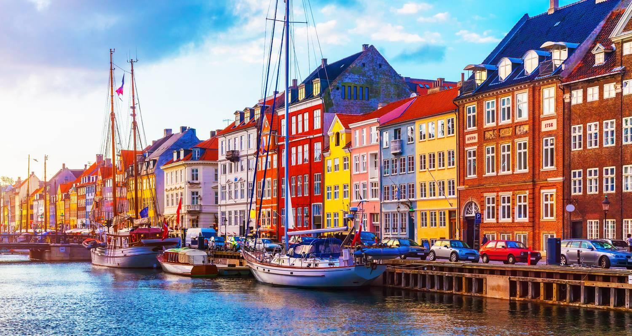

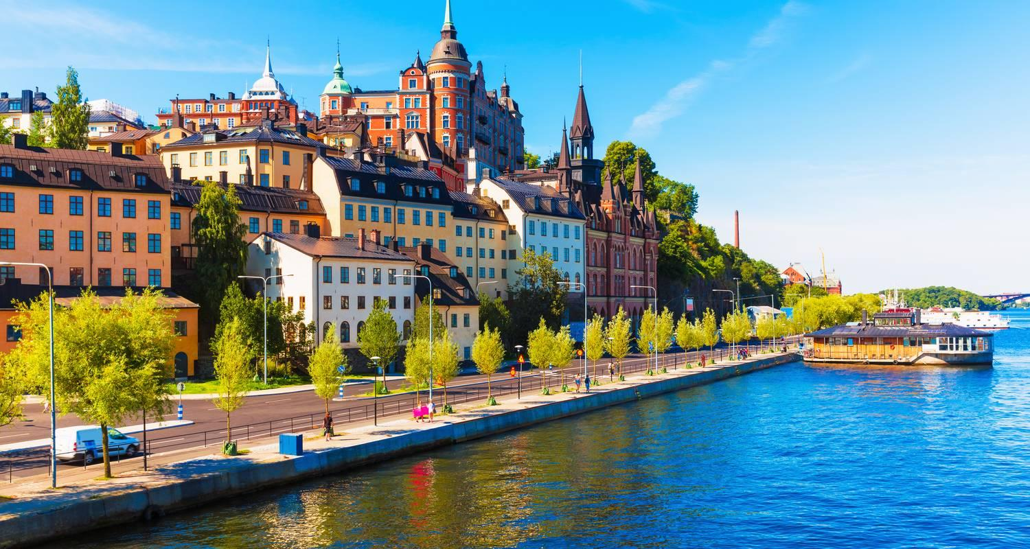

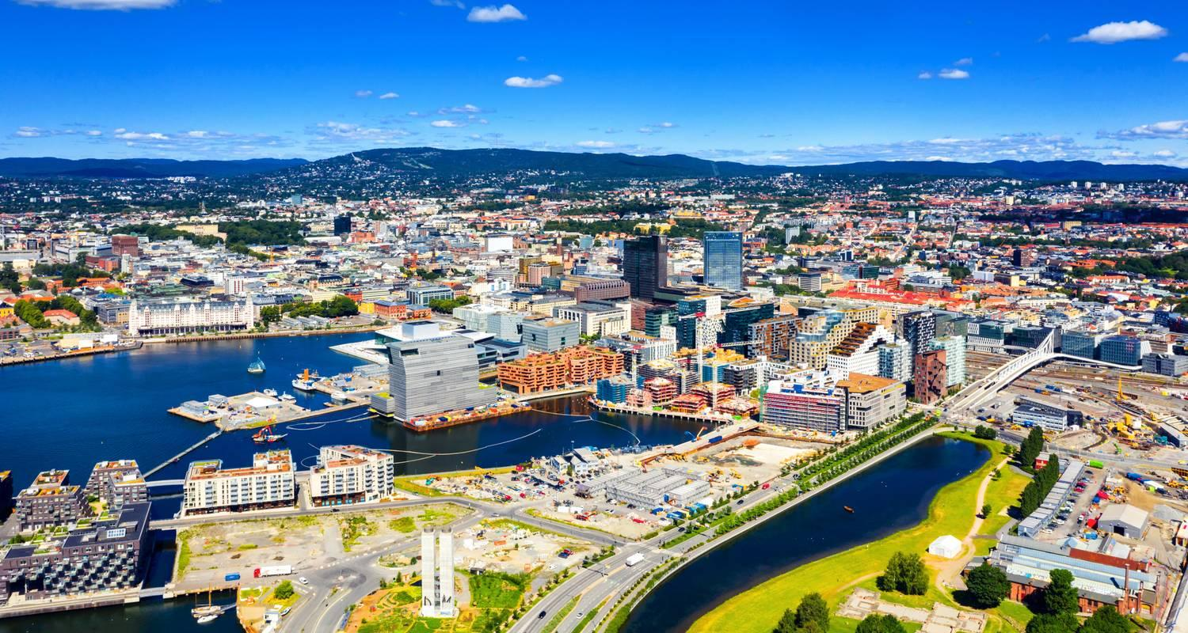

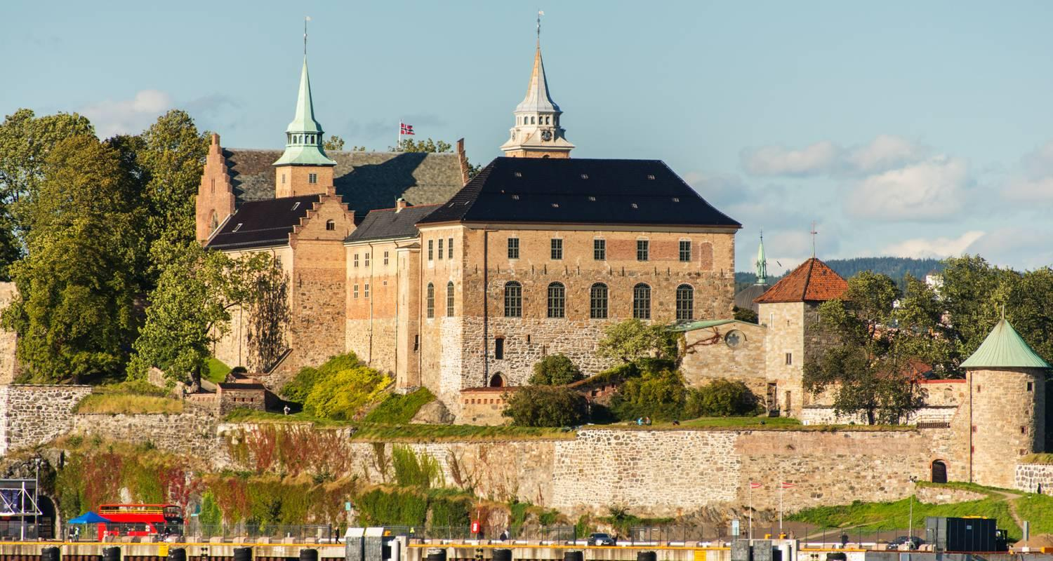

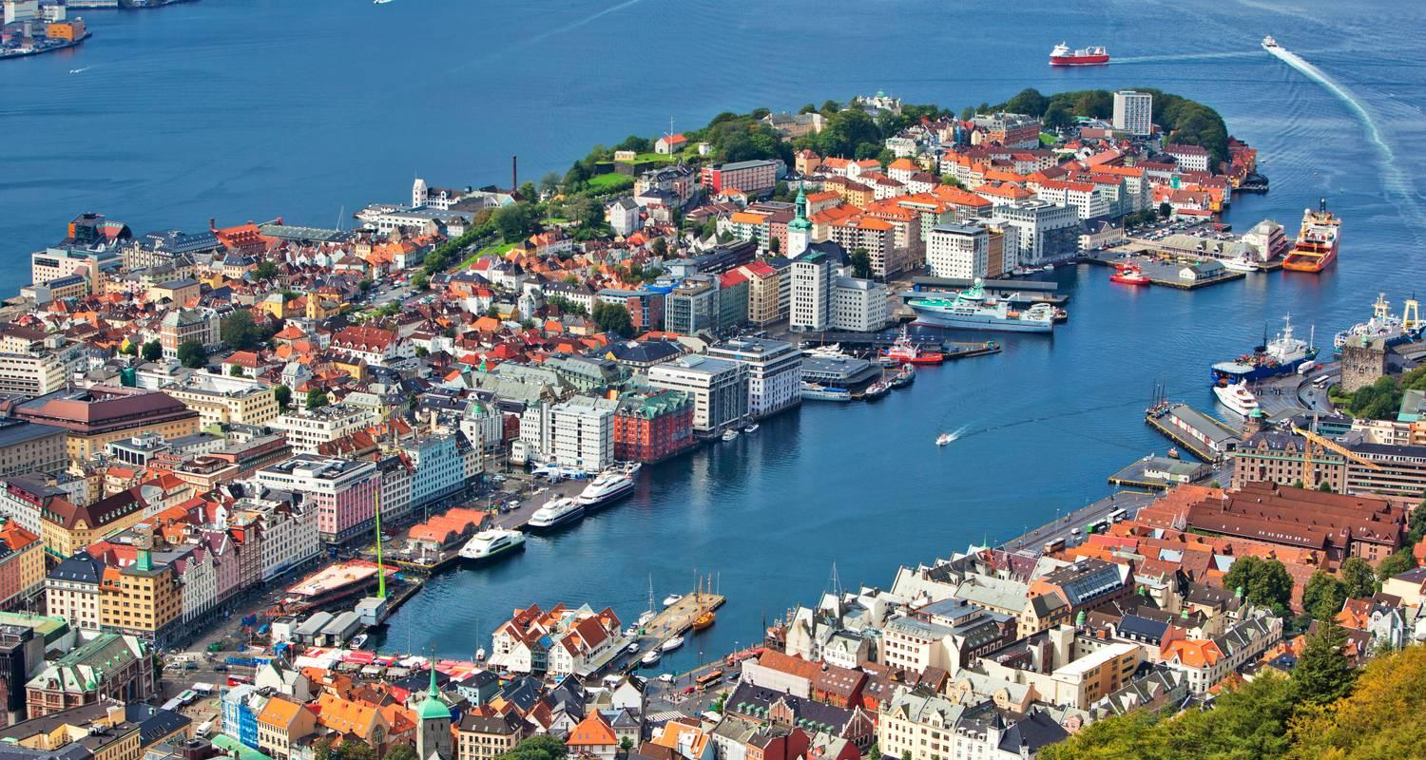

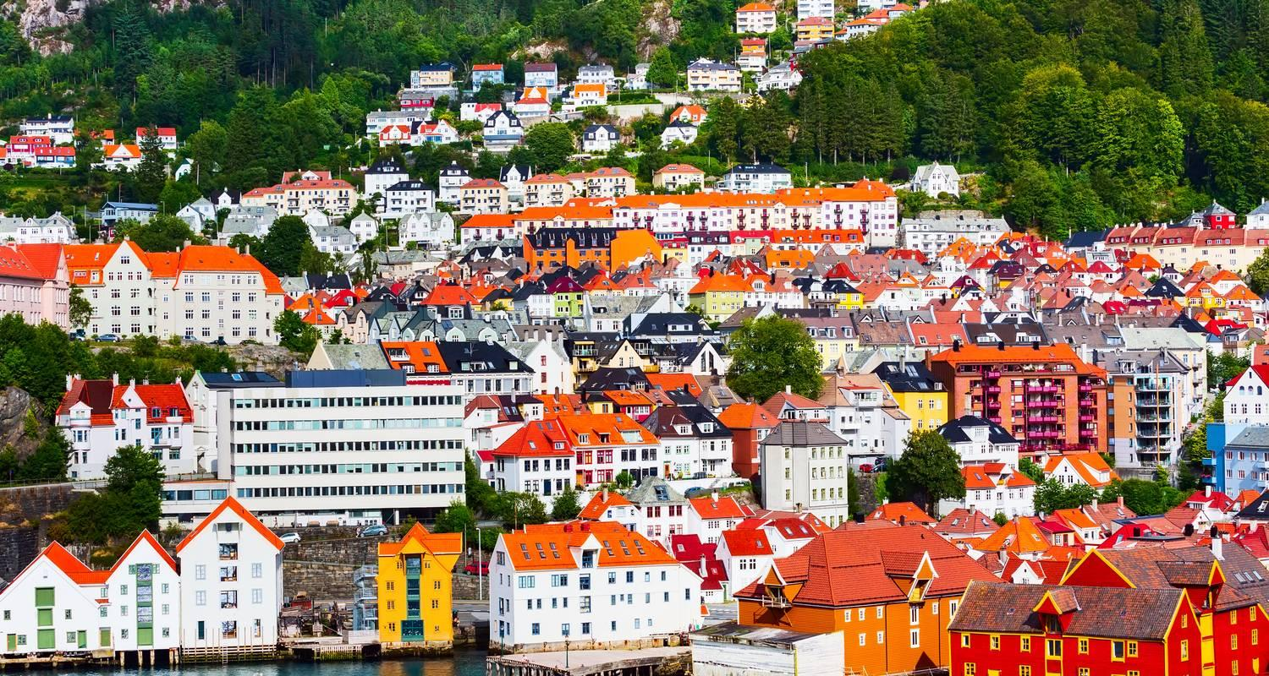

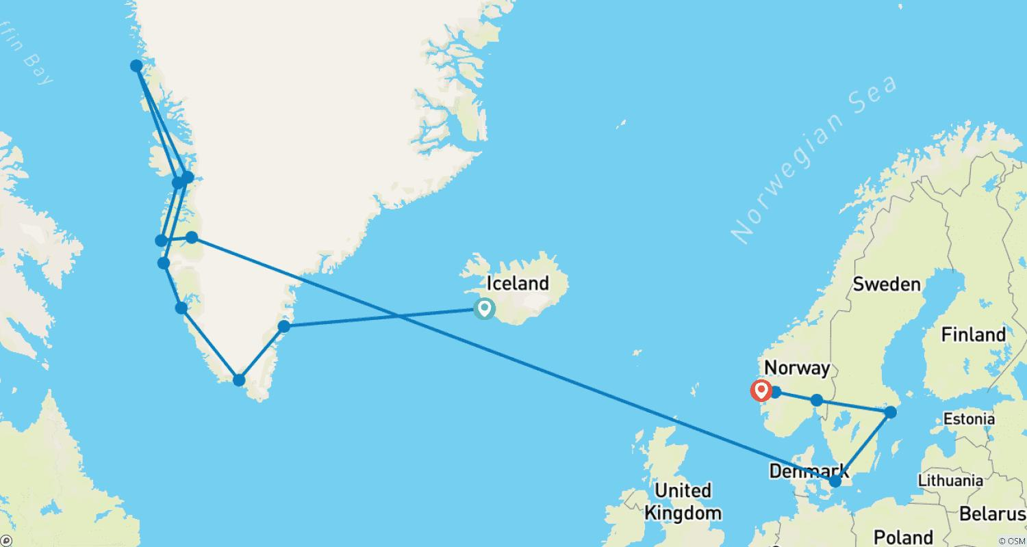

Tour ID: 229494  
Tour Name: Eastern Greenland Expedition & The Land of Fire & Ice - a cruise & land journey

Tour destinations: ['Reykjavik', 'Isafjordur', 'Ittoqqortoormiit', 'Kong Oscar Fjord', 'Grundarfjordur', 'Borgarnes', 'Gullfoss', 'Geysir', 'Kirkjubaejarklaustur', 'Blue Lagoon']

Tour destinations images:

